55 Whitehall  
 London  
 SW1A 2HP

Delivered via email: onshorewind@energysecurity.gov.uk

6 August 2025

**RenewableUK response to: Updated Guidance for the Assessment and Rating of Wind Turbine Noise**

**Consultation on proposed updates to technical guidance for the assessment of noise emissions from onshore wind turbines**

About RenewableUKRenewableUK members are building our future energy system, powered by cleanelectricity. We bring them together to deliver that future faster; a future which is better for industry, billpayers, and the environment. We support over 500 membercompanies to ensure increasing amounts of renewable electricity are deployedacross the UK and access markets to export all over the world. Our members arebusiness leaders, technology innovators, and expert thinkers from right across industry.

Dear Onshore Wind Team,

On behalf of RenewableUK members, we welcome the opportunity to respond to the consultation on Updated Guidance for the Assessment and Rating of Wind Turbine Noise.

Please see our full responses to the consultation questions below.

Yours sincerely,

**Heidi Douglas-Osborn**

Senior Policy Analyst

heidi.douglas-osborn@renewableuk.com

Overview

RenewableUK remains broadly supportive of the existing ETSU-R-97 guidance, which has provided a consistent framework for assessing wind turbine noise. We recognise and appreciate the work undertaken in developing the new guidance, particularly in its aim to streamline the framework and make it more user friendly. However, in seeking to streamline and update the guidance, the draft introduces a number of unintended consequences. These include the potential to negatively impact developments of all sizes, undermine the project pipeline, and hinder the UK’s ability to meet its clean power targets.

The ETSU guidance is meant to provide comprehensive advice to Local Planning Authorities (LPAs) across the UK for appraising planning applications for onshore wind developments. We encourage DESNZ to consider the following changes, which we believe could reduce planning times, maintain good standards and allow the UK to meet its Clean Power 2030 target:

* **Retain the separation of day-time and night-time limits:** The new guidance should retain the separation of the day-time and night-time limits.
* **Provide consistency:** The draft should aim to be more consistent in its language and tone as the current draft is ambiguous and creates confusion in its aims to streamline the process.
* **Introduce language in support of onshore wind deployment:** RenewableUK see the new language as more restrictive than the previous ETSU, resulting in less generation, which does not support the government’s Clean Power 2030 targets.
* **Additional guidance on small turbines:** We would like to see further guidance on small turbines and ask that turbines less than 100 kW be excluded from assessments to avoid noise budgets from being used up.
* **Review of overseas and national guidance:** Industry would like to see DESNZ complete the recommendations from the WSP report put into action – specifically a review of overseas and national guidance to provide further context for decisions on the policy balance between noise control and enabling renewable energy development. [1]

CONSULTATION QUESTIONS

**Aligning day-time and night-time noise criteria**

1. **Do you agree with our proposed approach of using a single ‘limit’, which takes the minimum of the day and night limit at each wind speed and applies at all times? Please explain your answer and provide supporting evidence.**

No, RenewableUK does not agree with the proposed approach of using a single ‘limit’ for day-time and night-time. We strongly recommend that DESNZ reconsider this and instead keep separated limits from the previous ETSU.

**Risk of curtailment**

We believe that this approach lacks clear technical justification and introduces unnecessary curtailment. This draft approach is a significant reduction in the noise limits when looking at sections 2.8-2.25, 2.34-2.40 and 4.3-4.4 and would affect projects of all sizes, and the UK’s onshore wind targets for 2030. This could result in over-constraining day-time operations, especially where day-time ambient noise levels are higher and accommodate more generation.

The lower limits will result in more turbines being curtailed, or a reduced turbine layout that would reduce the site capacity and more development sites would have to be secured.

**International noise limits**

It was highlighted that other countries maintain higher day-time limits that reflect real-world conditions. This recognises that background noise levels are typically higher during the day and that people are less sensitive to noise compared to night-time.

**Alignment with devolved guidance**

The approach in the guidance does not align with the control of noise in England[2], Scotland[3] and Wales[4], as well as BS 5228-1 and BS 8233 providing different limits, design levels and thresholds for day and night. Graph 1, ‘*Lower Limit of Noise Limits’,* illustrates one of the interpretations of the guidance, where the site-specific limit (the limit the site is consented to) can vary down to 10 dB below the proposed limit. The ETSU-R-97 limit is shown for day-time and night-time. (Provided by RWE Renewables)

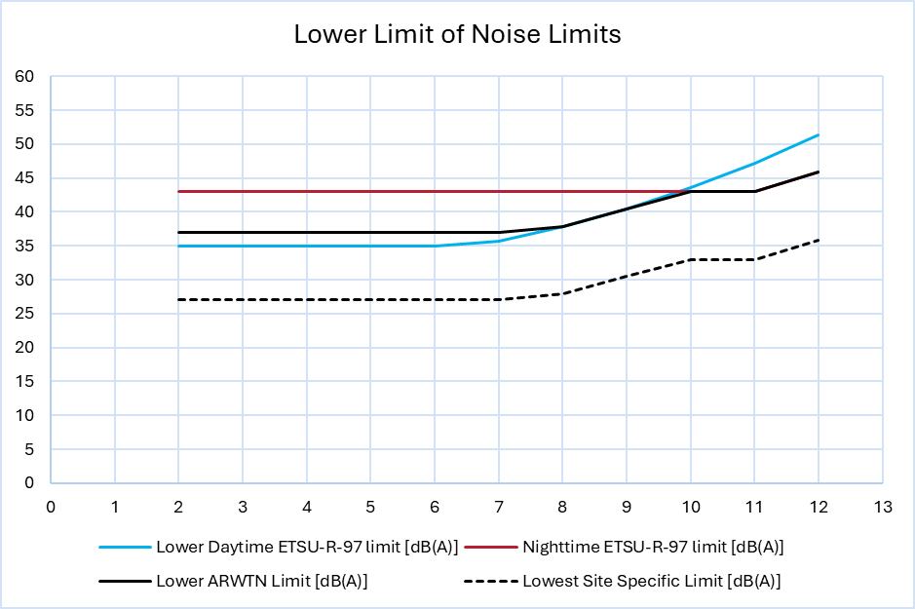

Graph 1: shows and example lower day-time ETSU-R-97 limit (solid blue line), with the night-time limit (solid redline), with the comparison of the draft guidance assessment limit (Solid black line) and the potential lowest site-specific noise limit (dashed black line)

**Raising the lower value for the day-time noise limit range**

1. **Do you agree with our proposal to raise the lower value for the day-time noise limit range to 37 dB? Please explain your answer and provide supporting evidence.**

RenewableUK does not agree with the proposal to raise the lower value for the day-time noise limit range to 37 dB. We strongly encourage DESNZ to reconsider this proposal, as this is expected to penalise larger projects that are critical to meeting national targets. It would likely allow small turbines (100kW) to consume disproportionate noise headroom limiting the viability of larger, more impactful developments.

Although England and Wales currently have a low number of small-scale wind turbines, lifting the de facto onshore wind ban in England has already led to planning applications predominantly for single-turbine schemes. As of April 2025, 14 applications for small, single-turbine project have been submitted suggesting small turbines are becoming the immediate focus of planning activity.[5] These installations may consume a disproportionate share of the available noise headroom, potentially pre-empting capacity that could otherwise support larger wind farms. That dynamic poses a conflict between small turbines and larger wind farms. As larger projects begin their application, they could face noise threshold constraints already occupied by small turbines, complicating delivery of broader clean energy targets.

The setting of the development noise limits described in Sections 4.3 and 4.4 negates any uplift from the raising of the 37 dB lower value, by further reducing the noise limit. The draft consultation guidance now states site-specific noise limit (SSNL) should be set less than the assessment criteria[6]. In addition, further reductions are compulsory in section 4.4

*“The following additional guidance shall be followed when setting appropriate noise limits:*

The noise limit should normally follow the same profile as the total criteria (not the predicted noise levels), reduced by a fixed amount at all wind speeds.”

There is an additional footnote, to this bullet point, that states “*the limit for the proposed development could for example be set at the assessment criteria minus the minimum margin between the predicted operational noise level and the total criteria”*

These sections are considered to be confusing, provides ambiguity with potential differing interpretations. This will delay planning decisions based on the opinion of the developer, Environmental Health Officer (EHO), Reporter/Inspector and Secretary of State. The text in these sections can produce a limit that could be up to 5 dB below the lowest background level. We suggest that Section 4.3, and the first bullet point from 4.4 shall be removed. These additional guidance points in new draft guidance were not highlighted in the WSP report and provide additional restriction in the deployment of onshore wind in the UK.

There is a lack of flexibility in the assessment, only allowing the LLV to be between 37 and 40 dB during day-time periods. A difference in sound level of 1 dB is only just detectable, to an average listener under test conditions, and a 3 dB difference is generally taken to be a noticeable difference, often corresponding to the volume change in a personal audio device.

**Alternative options for updating noise limits**

1. **If you do not agree with the proposed approach of using a single ‘limit’, what would you suggest as an alternative approach and why? Please include discussion of the appropriate dB noise criteria for your suggested approach and provide supporting evidence.**

RenewableUK suggests reintroducing day-time and night-time limits, as per the previous document ETSU-R-97 until there is sufficient evidence that supports a single limit approach and the recommendations from the WSP report are completed.

These approaches could better reflect real-world ambient conditions and international best practice. It would also avoid over-constraining projects during the day and allows for more efficient energy generation. This can be achieved through the recommendations of the WSP report, specifically the review of overseas and national guidance be undertaken, this recommendation has not been followed in the current draft guidance.

The approach suggested in this draft guidance does not follow national or international practice for setting limits for wind turbines. If the flexible approach from the previous ETSU is used then this would address the WSP report in the difference between day-time and night-time limits and would align the methods with international noise limits and the approach in BS 8233 & BS 5228.

**Amplitude Modulation**

1. **Do you think the updated guidance provides adequate advice for assessing and controlling the impact of Amplitude Modulation? Please explain your answer and provide supporting evidence.**

The updated guidance partially provides adequate advice, but further clarity is needed. We welcome the inclusion of an Amplitude Modulation (AM) character correction, however the application of any character correction greater than 0 dB for AM could result in site specific noise limits (SSNLs) being exceeded whilst the total noise assessment criteria is not exceeded. This potentially introduces a pass/fail criteria for any level of AM and creates the risk of unintended and excessive turbine curtailment being required.

We would instead suggest that AM character corrections are not applicable when assessing a site against SSNLs.

Similarly to appendix B for tonal analysis, the updated guidance should include worked examples of how the amplitude modulation analysis is applied.

1. **Do you agree with the other technical updates to the ‘Draft Assessment and Rating of Wind Turbine Noise Guidance’? Please explain your answer and provide supporting evidence.**

RenewableUK somewhat agrees with the other technical updates to the draft guidance.

We acknowledge and value the work of DESNZ, and the noise experts involved on the guidance, as the updated turbine profiles and planning condition templates and the clarification on financially involved receptors are particularly useful.

Where we have concerns are:

* That the assumption that all turbines are downwind simultaneously in cumulative assessment is overly conservative;
* That the draft omits guidance on wind speed standardisation (which can significantly affect noise predictions);
* And that the steering and peer review groups are referenced as the same organisations which raises concerns around independence and transparency.

The guidance update has removed key guidance on wind speed measurements and how to derive wind speeds at 10 metres from other hub heights, as previously outlined in the IOA’s Good Practice Guidance (GPG). Members recommend that either explicit reference to the relevant IOA GPG sections be included or that the new guidance document be amended to reinstate this guidance, as it is critical to consistent and accurate noise assessments. The assumption of all turbines being downwind in paragraph 2.37 implies that the directional corrections should not be applied to wind farms when considering cumulative if the wind farms are in different directions. This in effect means that there is up to a 10 dB penalty to account for the increased exposure.

It would also mean that curtailment that was applied would have to be applied in all directions, despite there being a reduction in noise levels under certain wind conditions. In addition, paragraph 2.17 suggests that the duration of exposure should be considered when setting the LLV, which we believe to be overly onerous and potentially counts the same phenomenon twice.

The cumulative constraints and downwind-only assumptions could lead to excessive curtailment, reducing energy output to the point where projects may no longer meet financial hurdle rates. This risks undermining investment viability and slowing deployment of clean power. Members have indicated that this approach could lead to capacity loss in some cases as wind turbines would likely need to be curtailed to meet site specific limits which are well below the background sound level.

We recommend that any factors acknowledged in the guidance as “difficult to define”, such as those referenced in paragraph 2.22, be removed. Including such ambiguous criteria risks inconsistent interpretation, delays in planning decisions, and undermines the clarity needed to support clean energy deployment.

The Existing IOA Good Practice Guide provides details of propagation directivity effects, but the use of these is not permitted under new draft guidance when assessing cumulative noise. Members believe this is an unnecessary restriction which could lead to excessive curtailment, and request that the exclusion of directivity owing to propagation is removed to reflect real-world acoustic behaviour. Should the authors of the draft consider that additional advice is required on the appropriate use of these effects, this should be provided via a future update of the GPG.

The examples in Appendix C suggests that only wind farms of 100 MW would be eligible for a 39-40 dB limit. At present the largest operational wind farm in England is the 68 MW Keadby wind farm and over 65% of current English wind farm capacity comes from schemes of between 1 and 30 MW. (Graph 2) Therefore, to meet the 2035 goal of 16 GW of onshore wind in England and Wales the equivalent of between 1 to 1.5 Keadby’s will need to be built per month for the next decade. To achieve this, these mid-range schemes will need higher noise limits as well as the very rare schemes of 100 MW and over.

The examples provided in the draft (e.g. 100 MW+ schemes) are not representative of the majority of UK onshore wind projects. To be useful, the guidance should include examples schemes between 20MW and 100MW, which are more typical and critical to meeting 2035 targets.

As mentioned above, we do not believe that the guidance should be applied to schemes under 100kW. Applying this guidance to all types of wind turbines except those allowed under permitted development rights will mean that multi-MW schemes will need to share noise budget with schemes of a few kW, making government generation targets harder to achieve. Assessing such small schemes will also mean that planning departments, that are already stretched, need to deal with many more schemes. Excluding these schemes (100 kW being the 10th percentile of English operational projects) could avoid noise budgets being used up by smaller schemes.

The scope of the guidance is tied to turbines not covered by permitted development rights, but with those rights currently under review, it is difficult to assess whether this scope will remain appropriate. We recommend that the final guidance be revisited once the updated permitted development framework is confirmed.

While the inclusion of example planning condition wording is welcomed, members have raised concerns that the timescales proposed for compliance and reporting are unrealistic. These could place undue pressure on developers and local authorities, particularly for complex or phased projects. We recommend that these timescales be reviewed in consultation with industry to ensure they are practical and achievable.

In the case of life extension of existing wind farms, the new limits will in some cases be lower than previously permitted. For operational sites that have operated without valid complaints, developers when seeking life extension should have the ability to retain the limits that have already been shown to allow the wind farms to operate without impact on residents.

Members recommend that the guidance confirm decimal values are acceptable, as they are often necessary for accurate cumulative assessments and reflect standard acoustic practice.

**Further comment**

1. **Do you have any further comments on the proposed updates to the ‘Draft Assessment and Rating of Wind Turbine Noise Guidance’ that you wish to make Government aware of? Please explain your answer and provide supporting evidence.**

RenewableUK is broadly supportive of the proposed update to the guidance, but we have concerns that aspects of the draft, if left unchanged, could inadvertently hinder the UK’s ability to meet its targets by over-constraining viable projects. This is particularly concerning given that we see no clear evidence the proposed limits have been tested against the UK’s net-zero objectives.

There is also worry around the reference to future documents such as the Institute of Acoustics best practice, which has not yet been published, creating uncertainty. It would be of benefit if the replacement for ETSU-R-97 incorporated current best and good practice.

The UK’s previous ETSU guidance was widely regarded as balanced and effective, but more clarification would be beneficial. It is important that the new draft build on that legacy, not replace it with more restrictive and ambiguous rules.

We welcome the clarification that infrasound, ground-borne vibration, and low-frequency noise are excluded from assessment at the planning stage. This aligns with current scientific understanding and avoids unnecessary complexity in the planning process.

Annex

Graph 2

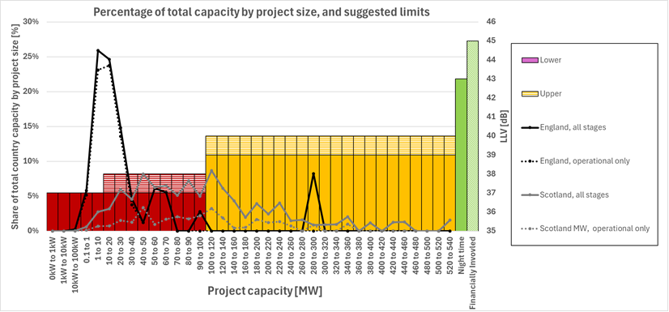

*The graph shows the percentage of overall wind farm capacity in England (black line) and Scotland (grey line) for projects of a given scale. Solid lines indicate projects at all stages (operational, consented, in planning, in development) whereas dashed lines indicate operational sites only.*

*In England 26% of the overall capacity comes from projects that are between 1 and 10 MW, and 23 % of the capacity is already operational. In England and Wales 99% of projects and around 75% of the total capacity comes from projects less than 100 MW.*

*In Scotland 9% of all wind capacity comes from projects that are between 100 and 120 MW and 3 % of the capacity is already operational. In Scotland over 90% of projects and over half of the total capacity comes from projects less than 100 MW.*

*The bars show the limits that are suggested in the examples in Appendix C, with colours indicating their relative impact on development.*

(Provided by OnPath Energy)

1. Report for UK Government: a review of noise guidance for onshore wind turbines - UK Government-commissioned review of noise guidance for onshore wind turbines by WSP Consulting. (2023) https://www.wsp.com/en-gb/insights/wind-turbine-noise-report
2. https://www.gov.uk/guidance/noise--2
3. https://www.gov.scot/publications/technical-advice-note-assessment-noise/pages/6/
4. https://www.gov.wales/noise-soundscape
5. Onshore wind projects still scarce in England despite planning reforms , Financial Times, (July 2025) https://www.ft.com/content/0bd69f7d-534b-42fb-a3a1-d5008d6ed942
6. Section 4.3 states: Operational noise from wind turbines developments should be controlled through the application of **site-Specific Noise Limits** (SSNLs) that apply to noise solely from the **development being consented**. The SSNLs **should normally not be set equal to the total noise assessment criteria in section 2** where it is not necessary to do so in order for the site to operate without unreasonable restriction (i.e. where there is a sufficient margin between operational noise levels and the assessment criteria).