Email to:
tnuosreform@ofgem.gov.uk
05 November 2021

To whom it may concern,
Call For Evidence – Transmission Network Use of System Charges
Scottish Renewables is the voice of Scotland’s renewable energy industry, working to grow the sector and sustain its position at the forefront of the global clean energy transition. We represent around 260 organisations across the full range of renewable energy technologies in Scotland and around the world, ranging from energy suppliers, operators and manufacturers to small developers, installers, and community groups, as well as companies throughout the supply chain.
Scottish Renewables welcomes the opportunity to provide written evidence to Ofgem into the call for evidence on Transmission Network Use of System Charges (TNUoS).
TNUoS presents a complex challenge for our industry, and it is also a long-standing issue that needs to be addressed as we move to a low carbon energy system. The need for reform is becoming more urgent as we seek to deploy large levels of renewable technology to meet our net zero targets.
In responding to this consultation, we would like to draw your attention to the following points:
- It is essential that there is a wider reform of TNUoS to meet the following criteria: Net zero alignment, stability & predictability, cost-reflectivity and recognition of geographic diversity of renewables.

- The main elements of TNUoS methodology that are driving the current disparity on locational charges are in the wider tariff, specifically in the Year Round Shared and Year Round Not Shared elements. Therefore, a review of these elements is critical as they are the ones who are driving volatility and leading to the misalignment with net zero.

- The use of multipliers can help to mitigate volatility and the disparity on locational charges. Multipliers could also lead to a more cost reflective regime.

- A task force approach seems to be the best vehicle for change to carry out this reform. We also suggest this reform be led by Ofgem and BEIS, as this will require strong leadership from a suitable independent body with expertise of network charging and commercial awareness to meet government ambitions.

- Flexibility will become increasingly important as we move to a renewable-based energy system. Hence, we consider that the flexibility and locational benefits of storage, particularly Large Scale and Long Duration Storage (LLES), should specifically be taken into account in the design of transmission charges, recognising and thereby incentivising the value that these assets provide.

- A suitable timeline for reform should be between 2 and 3 years in line with the OTNR.

Scottish Renewables would be keen to engage further with this agenda and would be happy to discuss our response in more detail.

Yours sincerely,

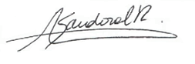
Angeles Sandoval
Policy Manager | Networks & Markets
Scottish Renewables

- The extent to which a broader review of TNUoS would be beneficial.

Back in 1992, the charging system was designed to provide clear signals to the energy market to incentivise developers to build fossil fuel power stations close to demand. Today, as we move to a smart, decentralised and renewables dominated energy system, this charging design is no longer fit for purpose and an updated system which balances the strengths of different parts of the UK is needed.

We believe that TNUoS requires an extensive reform that should meet the following criteria: Net zero alignment, stability & predictability, cost-reflectivity and recognition of geographic diversity of renewables.

  - Net zero alignment

The current TNUoS regime is not fit for purpose to meet either the Scottish Government or UK Government’s net zero climate targets. This regime is leading to disproportionate charges by location that are damaging the deployment of the renewable technologies needed to achieve net zero. We believe that there is a strong case to review the transmission charging methodology to ensure that the development of renewables is not discouraged where resources are most abundant. The need for review is even more pronounced given the ongoing review and reform of the offshore transmission arrangements.
To achieve the UK net zero targets, we need a steep increase in renewable energy installation by 2050. According to the Climate Change Committee (CCC) in the Sixth Carbon Budget, renewable deployment by 2050 should be between 95GW and 125GW for offshore wind, between 75GW and 85GW for solar PV, and between 30GW and 35GW for onshore wind. This is a dramatic increase in renewable deployment; therefore, we would expect that regulation moves forward at pace to facilitate the deployment of renewables across the whole UK and should not constrain this in any way.
TNUoS is designed to encourage generation to be located close to demand, however, to reach the level of renewable deployment required by 2050 we will need technologies to be located across the whole of the UK where the renewable resource is available. The locational factor becomes more pronounced when we analyse this by technology. According to the 2021 FES report, in the consumer transformation scenario, we will need 44GW of onshore wind by 2050, which in terms of resource is mostly expected to be deployed in Scotland. However, current TNUoS charges are disproportionally large in Scotland, which is reducing Scottish renewable deployment and our ability to reach net zero. This problem will not be solved with more onshore wind deployment in southern GB due to considerable planning barriers and low load factors in those areas.
Additionally, we note that the southern North Sea is becoming increasingly congested, with offshore wind projects seeking space to operate alongside many other users with recent development announcements targeting northern areas of the North Sea off the coast of Scotland. Similarly, land for large scale solar energy sites in the south of England is becoming progressively more difficult to find. Overall, Scotland’s renewable resource will gradually become more important to supply the energy we will need to meet our climate targets, but the current charging regime is constraining deployment in those areas, making the task very difficult to achieve.
With regards to offshore wind, we note that TNUoS is making Scottish projects less competitive in recent CfD allocation rounds, as it is not a cost that developers can control. From the auction rounds AR1, AR2 and AR3 results available through BEIS website (see table below), it is possible to see that the capacity awarded to offshore wind Scottish projects has decreased from 39 % in AR1 to 9% in AR3.

Auction Round | Total offshore wind capacity awarded (MW) | Capacity of offshore wind Scottish projects (MW) | % Capacity awarded to Scottish projects
AR1 | 1162 | 448 | 39%
AR2 | 3196 | 950 | 30%
AR3 | 5466 | 466 | 9%

With respect to AR3, we would like to note that several Scottish projects that were ready to build were unsuccessful in winning contracts. These include the 90-turbine Moray West Offshore Wind Farm (sister project to the Moray East wind project) and Red Rock Power’s Inch Cape Wind Farm off the Angus coast. Similarly, several other remote island wind projects were also unsuccessful, such as the Viking Wind Farm joint venture between the Shetland community and SSE. These projects are located in areas of high wind resource and the developers have optimised these projects to minimise costs to consumers but the more hostile conditions in the north make these projects slightly more expensive than those in the south. When TNUoS charges are loaded on top of this, these projects struggle to compete despite offering high loads factors.

This situation is expected to become worse without any action. According to National Grid ESO tariffs, TNUoS charges in Scotland have increased from 11 £/kW from 2016 to 26.35 £/kW in 2021. Locational charges are at odds with other policy levers, and thus do not act as the incentive they are designed to be, but instead become market distorting. Ofgem needs to consider the wider policy environment, including delivering net zero in its charging design.
Finally, we would like to note that a recent report by RIDG showed that the UK has among the highest locational charges in Europe; indeed, one of the few countries that charges a locational element for transmission charges. This is putting UK generators in Scotland at a disadvantage to European generators. As we become more interconnected with Europe, the TNUoS methodology is incentivising the system operator to import (potentially more carbon intensive) power over the interconnectors, at the cost of lower deployment of renewable generation in GB, and increasing reliance on the interconnectors for security of supply.

  - Stability and predictability

TNUoS charges are intended to provide an efficient price signal to generators. However, TNUoS volatility sends an inefficient signal for developers and investors, increasing the capital cost of projects that will ultimately cost energy consumers more. According to a report conducted by NERA consulting, consumers could face costs between £122 million and £391 million per year by 2030, if finance risk for future wind project resulting from TNUoS is not addressed.

TNUoS charges represent a large proportion of the operational costs of renewable generation. While TNUoS charges are only 2% of the operating costs of a combined cycle gas plant, they are around 30% of the operational cost for renewable generation. Hence, volatility is not a minor risk for renewable generators.
In research conducted by SSEN Transmission they found:
- Generators see swings in their TNUoS charges, typically over 50% up or down each year.
- Charges are unpredictable – Using National Grid’s own data, the average forecast error under-estimated the actual charge by one third.
This volatility is in sharp contrast to the total revenue allowed of the TOs that TNUoS charges are set to recover. The cumulative allowed revenue of NGET, SPEN and SSEN Transmission has been stable, within 5% of £2.5 billion, over the past five years. Investors need cost certainty and clear, forecastable TNUoS when planning and delivering long-term investments at lowest cost of the UK consumer. We also note that price volatility is a significant challenge for operational sites, where projects have been built and financed at a specific point in time based on the best view of TNUoS. Once final investment decision has been taken, these projects cannot react to changes in locational signals and therefore volatility in TNUoS costs simply adds risk to the projects. Volatility and unpredictability are not unique to Scotland but experienced by all generators regardless of technology or location. This uncertainty leads to increasing risk margins for developers, ultimately increasing costs that will be passed onto consumers.

The issues mentioned previously become particularly important given the scale of investment in wind generation expected to meet the 40GW of offshore wind target by 2030. Offshore wind not only faces high swings associated with the locational factor in the TNUoS methodology, but also faces high costs associated with the local circuit tariff, which today can be up to 48 £/KW.

According to another research conducted by SSEN, they found that:

- There is no apparent value in the locational ‘signal’ to offshore wind farm developers
- The lead time for offshore wind farm development is such that investment decisions and CfD bidding are made without confidence in future transmission use of system charges
- There are demonstrable impacts of transmission charge unpredictability and volatility on offshore wind farm costs and, hence, the cost to energy consumers.

Volatility and unpredictability of TNUoS are significant issues for renewable generators today, so we believe that the charging regime requires quick fixes to address these issues urgently.

  - Cost-reflectivity

In the recent ‘Access and Forward-looking Charges Significant Code Review: Consultation on Minded to Positions’ Ofgem published alongside the consultation a quantitative analysis carried by CEPA-TNEI. This analysis shows the charges that small distributor generators would face if they paid TNUoS charges up to 2040 (see table below).

The table shows the disparity of charges by location, which is the same issue we have exposed previously at transmission level. We can see a strong signal to incentivise fossil-fuel generation anywhere in England or Wales, and even to pay TNUoS credits to fossil-fuel generation throughout Scotland, despite the principles which TNUoS was designed to deliver. On the other hand, the only generation making payments for wider TNUoS is low carbon conventional and variable renewables in Scotland alone (zone 1 and 2). These outcomes are hard to reconcile against cost-reflectivity, nor against reasonable regulatory uncertainty for existing generators. Above all, these outcomes are hard to reconcile with the deployment of variable renewables required to meet net zero pathways.

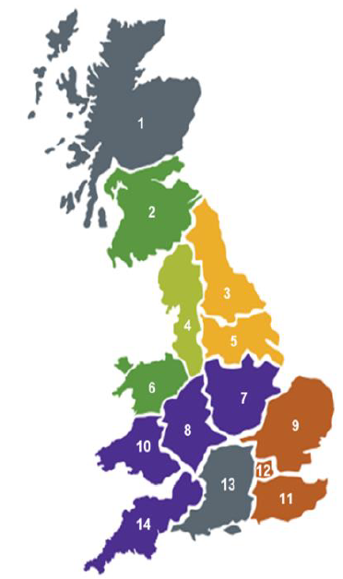
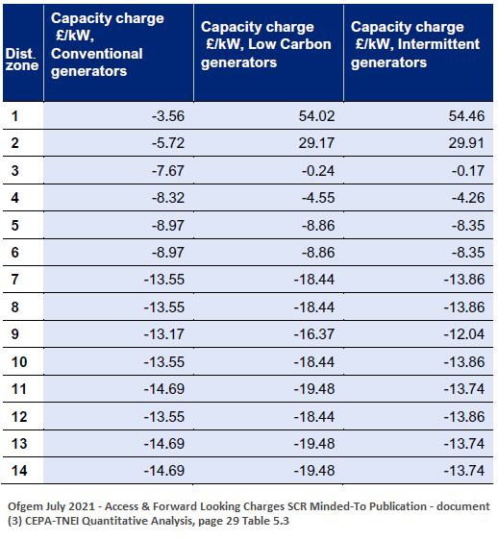
Table 1: 2040 Forecast charges for Small Distributor Generators.

We are aware that this forecast illustrates the charges that small distributor generators would face if they paid TNUoS charges which is not the case yet. However, we believe that this is a fair representation of the current regime at transmission level and is strong evidence to review the cost reflectivity of the current regime.

When we analysed cost-reflectivity at the voltage level we found further distortions. Today, while generators connected at 132 KV lines in Scotland are classified as transmission connected, in England and Wales they are considered as distribution connected. This leads to significant differentials:

- Generators in Scotland are required to pay balancing services charges while those in England and Wales are not
- Generators in Scotland pay transmission network charges while those in England and Wales either receive credits under the Embedded Export Tariff (in the South) or pay no charge
- Generators in England and Wales pay distribution network charges

Scottish Renewables recently commissioned research with Cornwall Insight to look at these differentials in more detail. The modelling identified that the disparity in charges between England & Wales (E&W) and Scotland are significant, being greatest for onshore wind, but still high for solar and hydro. The overall difference for a 40MW onshore wind site in Scotland was shown to be £1m higher than in E&W. The figure below illustrates this in more detail.

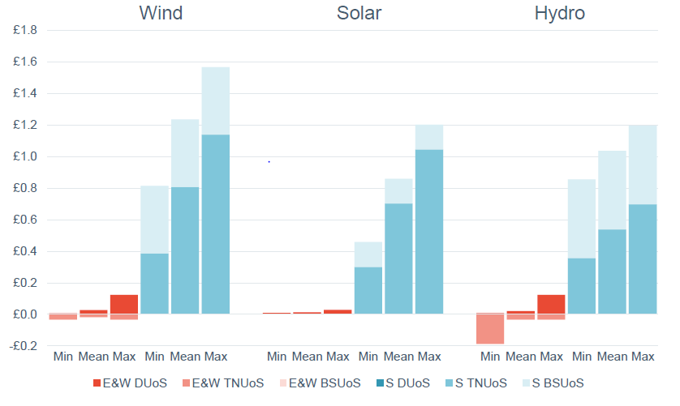
Figure 1: Cornwall Insight. Modelled network charges for 40MW 132kV wind, solar and hydro,
2021-22 (£mn)

We believe that this disproportionately disadvantages Scottish Users, a situation which is made worse under new arrangements in the positioning of the connection boundary proposed in the recent “Minded to Position consultation”. Where Ofgem is proposing to recover the costs associated with transmission that are triggered by a distribution connection – in England & Wales this connection will receive no reinforcement cost signal whereas in Scotland the user will be liable for the full cost in advance for the 132kV substation reinforcement. This distortion already exists but is made worse by the proposed change in connection boundary. Acknowledging the SHEPD and SPD “DG heat maps”, it can be seen that a significant majority of 132kV “GSP” substations across Scotland are close to or at their capacity to accommodate further generation, which means that this problem is substantial.

Additionally, if code modifications CMP315 and CMP375 progress unfavourably, charges for 132kV connected generators in Scotland will increase significantly more.

  - Recognition of geographic diversity of renewables

The current charging regime is designed to incentivise generators to locate close to the demand. In a fossil-fuel based system where fuel can be transported to generation sites, this makes some sense, in a renewables-based system where generation location is dictated by resource and site availability, it does not. The current system is incompatible with the decentralised energy system of the future that the UK Government envisioned in the 2020 Energy White Paper. Regulation does not exist separate to policy. If the Government’s preference is to increase and decentralise the deployment of cost-effective renewables and flexibility as a key element of achieving the net zero target, regulatory processes and the charging regime must not constrain this.

The UK has diverse renewable resources that can be deployed across the whole country, with one of the best potentials for onshore and offshore wind. We believe that energy diversification is important to provide energy security and long-term sustainability transitions. Currently, solar PV is almost the only intermittent renewable technology which has good load factors close to the demand (south), which means that the current regime discriminates against other technologies that are driven by resources that are mostly located in the north of GB. We understand that most of the new solar resource is expected to be connected to distribution networks rather than to the transmission system, but we are also aware that Ofgem is considering the extension of the TNUoS regime to distribution level. Hence, we think that if future TNUoS reform is to be applied to distribution level as well, then it is important to consider the whole system effects of the reform and take this into account in any change proposed. Without TNUoS reform the UK will not be able to achieve the envisioned energy diversity and fulfil the potential for a net-zero electricity system from UK resources.

We would like to highlight a recent report developed by Aurora Energy Research which analyses two possible scenarios for the deployment of wind energy. The first scenario analyses the case in which wind capacity is built predominantly in regions with attractive load factors (Scotland and the North Sea). The second one analyses the scenario where more wind resource weighting is given to locational price signals (i.e. TNUoS) and planning requirements are assumed to be relaxed, resulting in lower wind buildout in Scotland in favour of the England and Wales. Overall, the results indicate that if the system is driven by the second scenario this would lead to a more volatile power system and require higher wind generating capacity in GB to reach net zero by 2050. These effects lead to changes in market prices, with potentially negative implications on power plant economics and consumer costs in the long term, counteracting benefits from the alleviation of grid congestion.

The key findings of a system driven by the second scenario are:

- The increase in volatility due to a more correlated wind fleet:
- This leads to an increase in wholesale price volatility, with the spread between the 90th and 10th percentile prices reaching ~5% in the early 2040s, adding to the challenges of managing merchant risk exposure
- Wholesale capture prices for wind are slightly lower, potentially requiring higher CfD bids to meet investor hurdle rates.
- The need for energy balancing also increases, with net imbalance volumes increasing by ~3% in the mid- 2040s, alongside a small increase in imbalance prices, potentially contributing to higher balancing costs for consumers and generators.

- The network will require 5-6 GW additional wind capacity in GB to reach net zero by 2050 which will need to be supported by a faster buildout of battery storage. These changes to the capacity mix could lead to higher Capacity Market prices in the long run, particularly from the late 2030s onwards, potentially contributing to higher consumer bills.

We believe that TNUoS reform must recognise the geographic diversity of renewables and the benefits of a diverse mix of generation alongside this. Renewable generation is driven from where the resource is most abundant, and the charging regime cannot keep ignoring this. We have shown extensive evidence that demonstrates that the energy system from 2030 onwards will be driven by low carbon generation, so we believe that allowance for renewable resource location is something that should be addressed in this reform.

- Priority areas for reform

  - Wider Tariff

Today, the wider tariff is the main element of the TNUoS methodology that is driving the current disparity on locational charges. The following extract from a report by National Grid ESO shows the forecast of wider tariffs for 2022/23. From this it is possible to see that the tariffs for intermittent technologies in the north of Scotland are extremely high compared to those in England and Wales. North Scotland tariff is around 25 £/KW while West Devon and Cornwall tariff is -3.9 £/KW (see table below).

Table 2: National Grid ESO. Generation Wider Tariff, p11.
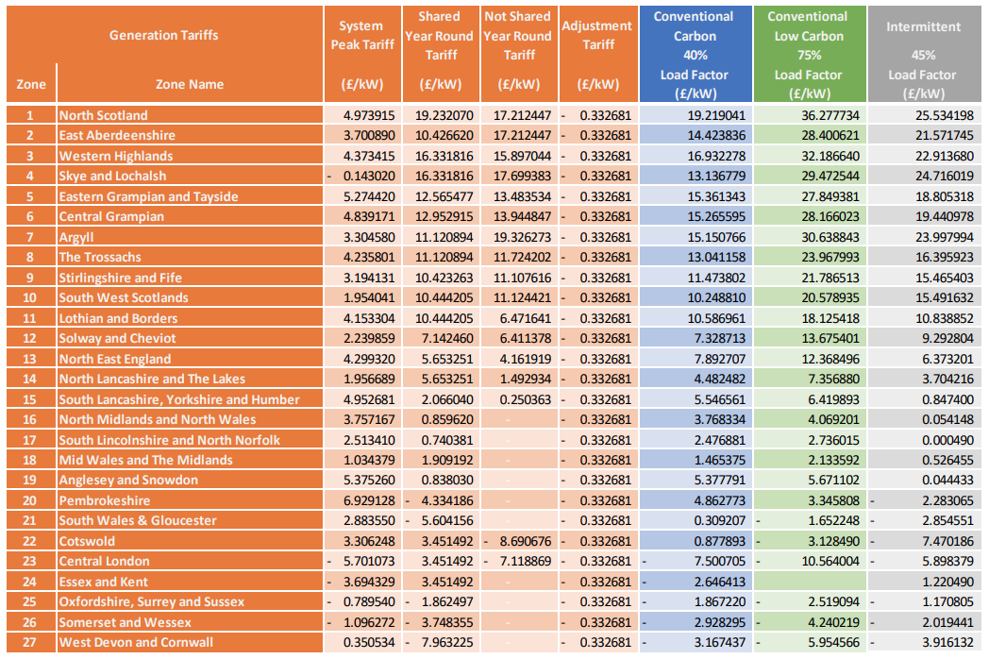

The main elements of the wider tariffs for intermittent generators are illustrated in the figure below.

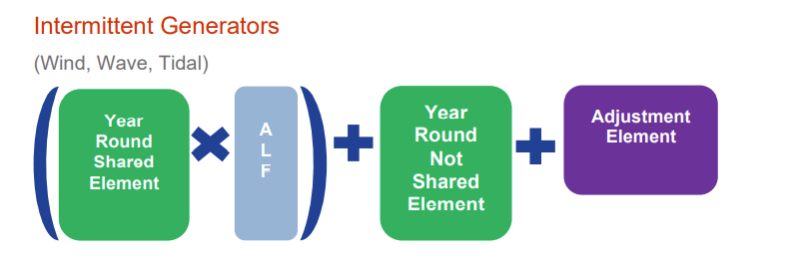
Where:
- ALF= Annual load factor
- The Year Round Shared and Year Round Not Shared. These elements represent the proportion of transmission network costs shared with other zones, and those specific to each particular zone respectively.
- Adjustment element is a flat rate for all generation zones which adds a non-locational charge (which may be positive or negative) to the Wider TNUoS tariff, to ensure that the correct amount of aggregate revenue is collected from generators as a whole.
We think that the Year Round Shared and Year Round Not Shared elements of the wider tariff require a review in order to have a more cost reflective tariff in alignment with net zero. These are the elements specific to each particular zone, hence these are the factors of the methodology that are driving higher costs in northern areas.

    - Use of multipliers in the charging methodology

Ofgem is proposing to consider the use of multipliers in the locational charging methodology. Although today there are live CUSC modification proposals (CMP315 and CMP375) in respect to the expansion constant, the use of multipliers could potentially offset the current disparity of charges and help with predictability, stability, and cost-reflectivity of the charging regime.

  - Flexibility
In the consultation document, Ofgem suggests that further work in respect of charging arrangements for storage of all sizes may be warranted in the context of its potential to provide solutions to network issues rather than to act solely as a wholesale market participant. We agree that network charging is a key factor to consider in the policy regime for the development of storage, particularly for Large Scale Long Duration Storage (LLES). It will be important that the transmission charges appropriately reflect the value that these flexibility resources provide to the electricity system, both as demand and generation.
A critical function of LLES is to provide balancing and stability services to market and the network. LLES are not net MWh generators, but they are defined as generators and therefore the balancing and stability benefits (and cost savings from reduced network investment) are not reflected in the way their connection application to the grid is assessed. LLES is considered as just another generator and are connected on first come first served basis behind other generators. We believe that LLES can make a major contribution to a net zero electricity system, both enabling the rapid growth in variable wind and solar renewables and accelerating the displacement of fossil fuel generation.

We consider that the flexibility and locational benefits of LLES should specifically be taken into account in the design of transmission charges, recognising and thereby incentivising the value that these assets provide.

- Vehicles for change

We have assessed a few options to deliver this reform and we believe that the best vehicle for change will be a ‘Task Force’ approach. An open governance process is a very informal process that would not be appropriate for the scale of this reform. An SCR is not flexible in its delivery, and it could take a long period of time out of the timescales required for this reform. On the other hand, a ‘Task Force’ approach aims to help to identify options for a broad charging topic and support Ofgem in assessing these options. We understand that each Task Force is made up of volunteers who will actively contribute by: identifying options, producing impact assessments and engaging with wider industry participants. Therefore, we see this vehicle for change as a plausible option to deliver this reform.

We would like to note that we believe that this reform needs strong leadership from a suitable independent body. A body with efficient expertise of network charging and commercial awareness to meet government ambitions. In this context, we suggest that this reform must be led by Ofgem and BEIS, mirroring the way that the OTNR is being carried out.

- The timescales to which industry considers any reform programme should work.

A suitable timeline for reform should be between 2 and 3 years in line with the OTNR. There is an immediate need to address the fundamental problem of TNUoS charging methodology, which is no longer fit for purpose and needs urgent reform to help achieve the required growth of renewable generation to meet challenging targets to decarbonise generation. This urgent requirement suggests that a different approach to the usual CUSC modification approach is required and a Task Force with suitable expertise, independence and strong leadership needs to be implemented in a shorter timescale than normal.
In the call for evidence document Ofgem states that there are some ‘quick wins’ that might make a significant difference to the value of TNUoS charges through an improvement of cost-reflectivity. We would like to note that there are quick wins as a result of a most cost-reflective, predictable & stable regime and this is absolutely necessary to align this reform with net zero. Investment in areas of high renewable resource need to be unlocked to achieve our government targets and so regulation should move forward at a pace to facilitate this.

Climate Change Committee, (2020). The sixth Carbon Budget. Available https://www.theccc.org.uk/publication/sixth-carbon-budget/
National Grid ESO. Future Energy Scenarios (2021). Available: Future Energy Scenarios 2021 | National Grid ESO
Contracts for Difference (CFD) Allocation Round One Outcome - GOV.UK (www.gov.uk)
Contracts for Difference (CFD) Second Allocation Round Results - GOV.UK (www.gov.uk)
Contracts for Difference (CfD) Allocation Round 3: results - GOV.UK (www.gov.uk)
National Grid ESO (2021). 2021 tariffs. Available https://www.nationalgrideso.com/charging/transmission-network-use-system-tnuos-charges
RIDG (May 2021), Charging the wrong way. Available: https://cdn.ymaws.com/www.renewableuk.com/resource/resmgr/210524_tnuos_paper_final_for.pdf
NERA Consulting (2021). Quantifying the Risk of TNUoS Charge Volatility for Wind Developers
NERA Consulting (2021). Quantifying the Risk of TNUoS Charge Volatility for Wind Developers
SSEN, Transmission (Sept 2021). Offshore Wind Transmission Charges. Available: https://www.ssen-transmission.co.uk/media/5764/ssen-transmission-offshore-tnuos-addendum_.pdf
SSEN, Transmission (Sept 2021). Offshore Wind Transmission Charges. Available: https://www.ssen-transmission.co.uk/media/5764/ssen-transmission-offshore-tnuos-addendum_.pdf
Ofgem, Access & Forward-Looking Charges SCR Minded-To Publication (Jul 2021) – document (3) CEPA TNEI Quantitative analysis, page 29 table 5.3. Available: https://www.ofgem.gov.uk/publications/access-and-forward-looking-charges-significant-code-review-consultation-minded-positions
Cornwall Insight (Jul 2021), Charging differentials for 132kv generation. Available: https://www.scottishrenewables.com/publications/924-report-charging-differentials-for-132kv-generation
Grid Supply Point – the substations where the transmission system and distribution networks meet
UK Government (2020). Energy white paper: Powering our net zero future. https://www.gov.uk/government/publications/energy-white-paper-powering-our-net-zero-future
Aurora Research (2021). Impact analysis of different geographic distributions of wind generation in GB
National Grid ESo (Aug 2021). Forecast TNUoS Tariffs for 2022/23. Available: https://www.nationalgrideso.com/document/207346/download
National Grid ESo (Aug 2021). Forecast TNUoS Tariffs for 2022/23. Generator Wider Tariffs, p11. Available: https://www.nationalgrideso.com/document/207346/download

