Electricity System Team
Department for Business Energy and Industrial Strategy
3 Whitehall Place
London
SW1A 2AW

05 January 2017

Dear Sir/ Madam,
Call for evidence on a smart, flexible energy system
Scottish Renewables is the representative body for the renewable energy industry in Scotland, working to deliver a low-carbon, secure energy system, integrating renewable electricity, heat and transport at the lowest possible cost.
We share the view of the Government that a smarter and more flexible energy system offers significant benefits for consumers and the economy and will ensure that the UK has a secure affordable and clean energy system now and in the future.
It is our view that Government working alongside the regulator and industry will have a critical role in securing the benefits of this transition, focussing particularly on the following areas;
- Consistency: The transition to a smarter energy system will have far reaching impacts. It is therefore essential that government policy is consistent, transparent and clear. For example, there is some inconsistency with a policy that restricts the cheapest forms of renewable generation competing in the market when seeking to deliver a secure, affordable and clean energy system.
- Vision: The transition to a smart flexible energy system will create opportunities for industrial strategy, economic growth and international export. It is therefore important that government’s ambitions are not restricted to energy policy alone.
- Delivery: A number of the issues that must be addressed will cover a wider scope of policy and regulatory areas influenced by a number of actors. We would strongly encourage BEIS and Ofgem to coordinate a well-defined delivery plan to take forward any actions arising from this call for evidence. For example, it is important that other areas of regulatory reform (such as National Grid’s charging review) are aligned with the actions arising from this call for evidence.
- Focus: It is clear that much of the focus of this call for evidence is on the electricity market. While this is welcome, it is clear that a similar approach should be taken to consider the need for, and impact of, changes in the wider energy system including heat and transport.
Our responses to a number of the key questions from the call for evidence are set out below and we would be happy to provide any further information where required.
Yours sincerely,

Removing policy and regulatory barriers - enabling storage:

- Have we identified and correctly assessed the main policy and regulatory barriers to the development of storage? Are there any additional barriers faced by industry? Please provide evidence to support your views.

We are pleased to see a number of the barriers faced by energy storage developers identified within this Call for Evidence. Overall it is our view that storage urgently requires a clear definition, storage providers need visibility of required services and that flaws in the system, such as the double charging of final consumption levies need to be addressed.
Clarity as to what services storage can provide will be necessary to it reaching its full potential in our energy system. Continuing to develop clear and transparent tenders for services will be necessary as signals for investment, as well as developing clear guidelines for adding energy storage assets to existing generation sites.
An additional challenge is that the way storage will behave in the energy system will change over time. As more storage is deployed on the network, and existing assets stack new revenue streams the behaviour of storage on the system will change. System planning needs to take account of this complexity.
Similarly, different scales of storage technologies will impact the network differently and have different requirements to secure investment. For example, Pumped Storage Hydro offers a range of benefits to the system – including much needed inertial response and black start capability, yet it is unlikely that investment in this technology can be secured based on short-term contracts. The principle barrier Pumped Storage Hydro faces is policy uncertainty. DNV GL has reported that large-scale storage projects of this nature ought to be treated similarly to infrastructure projects, such as interconnectors. In line with the report’s findings, we would recommend that consideration be given to mechanisms such as a Cap and Floor, to enable these technologies to come to market.
- Have we identified and correctly assessed the issues regarding network connections for storage? Have we identified the correct areas where more progress is required? Please provide evidence to support your views.

We agree that quick and efficient connections for storage applicants are important, and support Ofgem’s work in that regard - including the work of the Energy Network Association’s DG-DNO steering group.
In addition, there is an increasing focus on the benefits that could arise through the publication of demand heat maps. These would direct storage provides to where to connect, and ensure the full benefits of storage are recognised in the system.
More sophisticated connection processes will also be required to accommodate flexibility providers including energy storage.
Storage assets have more complex network user requirements. Network operators must continue to develop to accommodate these assets, for example, by facilitating flexible connections and by adopting innovations such as Active Network Management.
Given the unique role of storage assets, a mechanism should be developed allowing storage to be treated differently in areas such as connection queue management. This would enable greater efficiency in the delivery of storage assets and maximise benefits to the network.
In sum, the impact storage will have on the network needs careful consideration in both the system planning and the connections process.
Clarity is also needed on the process for storage connections where they are connected to existing generation sites. Metering and aggregation mechanisms will be required to monitor site output, particularly where sites are in receipt of revenue such as ROCs.
We also repeat the call for the introduction of A&D fees- this would benefit storage applicants and all other applicants in the connection queue. DNOs are processing overwhelming volumes of applications. Critically, currently a large cost associated with applications that are not accepted is distributed across those that do end up contracting. Ultimately it is a cost picked up by bill payers rather than the parties that trigger DNOs to incur these costs. Industry has shown consensus on this matter.
- Have we identified and correctly assessed the issues regarding storage and network charging? Do you agree that flexible connection agreements could help to address issues regarding storage and network charging? Please provide evidence to support your views, in particular on the impact of network charging on the competitiveness of storage compared to other providers of flexibility.
We agree that guidance is required on charging methodologies for energy storage. The double counting effect of Final Consumption Levies is a particular issue and there is some concern that although his issue is identified within the call for evidence there is little detail on the governments planned next steps - we look forward to detail on further work in this area
In particular, storage needs clear definition in Security and Quality of Supply Standards. While much of the debate surrounds the SQSS and Engineering Recommendation P2/6 (intermittent/non-intermittent) we note that the choice should not be restricted to intermittent or non-intermittent. The more appropriate approach would be to develop a classification based on the actual and specific functioning of storage on the network.
We do caution that this is difficult without a clear understanding of how changes to address the growth of storage will impact other areas of network charging. National Grid has indicated that it intends to conduct a review of commercial arrangements for electricity network charging. Given the web of complexities and dependencies within network charging, we recommend that the consideration of network charging for energy storage is tackled holistically within such a review.
- Do you agree with our assessment that network operators could use storage to support their networks? Are there sufficient existing safeguards to enable the development of a competitive market for storage? Are there any circumstances in which network companies should own storage? Please provide evidence to support your views.

Energy storage assets can have clear benefits to the network; however our member’s preference is that network companies focus on running competitive tenders for third parties to own and operate storage.

We understand that there may be cases where there is insufficient incentive for developers to connect storage resources where they are needed, but that those resources would have a beneficial impact upon the network as a whole, such as freeing up capacity or the lower cost and shorter timescales of installing a battery unit rather than installing more cabling. However, network ownership and operation of storage brings a very high risk of market distortion (as has been signalled by the European Commission in the draft Clean Energy Package).

In exceptional circumstances we suggest that ownership of an asset must be approved by Ofgem, and sufficient mechanisms are put in place to consider whether it is in the best interests of the consumer and to assess the risk of market distortion. Ultimately this process should consider whether the market could provide a more cost effective solution. As current regulation would prevent a network operator from participating in generation and supply markets, we recognise this could create a missed opportunity, where assets on the network are not used to their full potential (i.e. a battery mitigating the need for a cable upgrade but, if owned by the network operator, unable to provide additional services). This may not be cost effective.

In general, therefore, we would encourage the provision of clear information as to where on the network flexibility solutions may be required. This should be reinforced with clear price signals to encourage energy storage to provide the required services at the appropriate points on the network. Network operators’ focus should be on creating markets for third party operators to compete in.

- Do you agree with our assessment of the regulatory approaches available to provide greater clarity for storage? Please provide evidence to support your views, including any alternative regulatory approaches that you believe we should consider, and your views on how the capacity of a storage installation should be assessed for planning purposes.
In general we support the progression of regulatory clarity for storage in order to provide certainty and clarity as soon as possible – the necessary first step is to determine a clear definition for storage.
We also encourage storage to be clearly incorporated into other network codes.

- Do you agree with any of the proposed definitions of storage? If applicable, how would you amend any of these definitions? Please provide evidence to support your views.

There is concern among industry that the variety of definitions appearing for energy storage could at best create confusion and at worst create disparity in how storage assets are treated. We welcome that Government and Ofgem are minded to define energy storage.
We also note that a definition would help address a number of barriers facing energy storage:
- Classification for network charging
- The application of queue management to energy storage
- Planning
- Final Consumption Levies double charging

Removing policy and regulatory barriers - Aggregators:
- What are the impacts of the perceived barriers for aggregators and other market participants? Please provide your views on: • balancing services; • extracting value from the balancing mechanism and wholesale market; • other market barriers; and • consumer protection. Do you have evidence of the benefits that could accrue to consumers from removing or reducing them?
- What are your views on these different approaches to dealing with the barriers set out above?
- What are your views on the pros and cons of the options outlined in Table 5? Please provide evidence for your answers.
- Do you agree with our assessment of the risks to system stability if aggregators’ systems are not robust and secure? Do you have views on the tools outlined to mitigate this risk?

Providing price signals for flexibility – System Value Pricing:

- What types of enablers do you think could make accessing flexibility, and seeing a benefit from offering it, easier in future?

It is important to note that a range of technologies from existing generation plant to new battery technologies, pumped storage and demand side response are all able to offer flexibility services. Accessing and realising the benefit of these services will require a balance of longer term reform to bring regulation and commercial arrangements in line with a modern clean energy system and short term ‘fixes’ to enable the system to move forward. Overall the objective should be to create a level playing field that allows all technologies to compete and ensures that the most efficient solutions are ultimately delivered for the whole system.
The Institute of Engineering and Technology (IET) recently estimated that by 2030 the number of generators providing services to the network will have increased from around 15 to over 600,000. However the current market for ancillary services was designed for a different time, where a smaller number of generators would provide service as an addition to the core commercial activity of generation.
‘Flexibility’ service providers operate under a different set of commercial drivers. For, example storage providers will look at the service market as core revenue. It is our view that there are three key revenue-based barriers to making battery storage projects financeable:
- Low bankability Revenue streams are not easily bankable from a private sector perspective.
- Revenue interface risk Revenue streams do not always match up from a timing, contractual and technical perspective.
- Lost potential: Flexibility operators cannot monetise the full range of services that their plant can deliver.

Much of the storage interest in the UK to date has focused on high power applications such as frequency response. But high energy applications with longer storage durations are of particular value to the system. As it stands the GB electricity system already benefits from 24GWh of pumped storage capacity, split across four sites, largely in Scotland. Around another 50GWh has planning permission – enough to cover close to the UK’s total peak electricity demand for an hour.
Revenue stacks need to attract cost effective debt and equity finance, to ensure that the lowest cost source of flexibility is able to access the market. This means designing revenue streams with investors and consumers in mind, reflecting the reality that the financial characteristics of new flexibility projects are different from those of the past. It is our view that the following changes are necessary to achieve this;
- Improving bankability: Some revenue streams to support system operation are only accessible through monthly tenders. Extending contract length, and possibly introducing a cap-and-floor regime for large projects with long lead times (such as pumped storage), would help reduce risks for investors. This would decrease the cost of finance, meaning that storage can be delivered at least cost.
- Addressing revenue interface risk: Ensuring that technically compatible revenue stream can work together is central to building the storage business case. Aligning tender timelines will help reduce the risk premium that investors assign to secondary revenue streams.
- Unlocking potential: Distribution network owners have been taking active steps to trial 'storage-friendly’ commercial innovations– ensuring that these innovations become business as usual through the transition to DSO will be a crucial step. Ultimately this should enable greater coordination between transmission and distribution allowing local markets for balancing services while avoiding conflicting and counter-productive system balancing actions.

- If you are a potential or existing provider of flexibility could you provide evidence on the extent to which you are currently able to access and combine different revenue streams? Where do you see the most attractive opportunities for combining revenues and what do you see as the main barriers preventing you from doing so?
Revenue streams for ‘flexibility service’ providers will typically be stacked or combined in a way that maximises impact and recovers the income necessary to secure investment, at acceptable risk. The optimal combination will vary over time and also according to a number of factors including risk appetite, technology and connection point.
The National Infrastructure Commission clearly sets out how a smart power revolution spanning storage, interconnection and demand response is worth up to £8bn to UK consumers.
To realise these savings, we need to ensure that the lowest cost technologies are able to provide the system with the services that it needs. The first step is to map out the key actors within the electricity system, and how flexibility services can help these actors better fulfil their role. Put simply, the potential beneficiaries from flexibility services fall into one of two camps – regulated monopolies (System operator, Transmission owner and Distribution Network Operator) and connected customers - organisations who have a profit or community motive, rather than direct regulatory obligation. They tend to act in competition, and are not natural monopolies.
Scottish Renewables commissioned consultants Everoze to set out the main revenue streams available to electricity storage providers, taking into account where they connect on the network and the ability of relevant parties to monetise the benefits.
The findings of that report can be seen below. The full report sets out more detail on each of the revenue streams including three case studies, a summary of the 14 revenue streams has been provided as an annex.

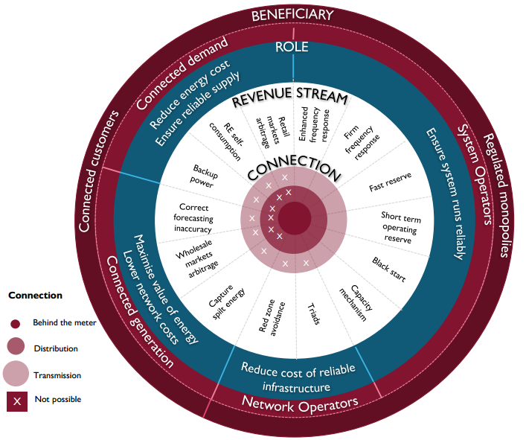

- If you are a potential or existing provider of flexibility are there benefits of your technology which are not currently remunerated or are undervalued? What is preventing you from capturing the full value of these benefits?

Ancillary Services
Renewable electricity generators already provide a number of system services including frequency response, reactive power and intertrip through contracts with National Grid the system operator (SO). Largely these contracts are procured from generators connected at transmission and therefore with an existing contractual relationship with the SO. However a number of distributed generation projects have been able to work with the SO and develop a contractual route to provide necessary services to the SO though their connection with the Distribution Network Operator (DNO).
As the system changes this could have the potential to create conflicting signals - particularly as DNO’s seek to take on the role of Distribution System Operators. In advance of this transition, services provided directly to the distribution network owner are not yet well defined - beyond existing innovation projects - and there is some uncertainty around the DNO’s ability to pass on cost savings to the service provider.
It is important therefore to ensure that embedded service providers contracting with National Grid do not drive costs for the DNO and where generators or other service providers are able to lower costs for the DNO that there is an appropriate mechanism to realise or recover this value.
Balancing Services
Through the balancing mechanism wind generators are able to connect to the electricity network in advance of reinforcement accepting curtailment at times where there is insufficient capacity on the network.
There are clear benefits to this system – allowing more low carbon generation to connect to the system and contribute to our electricity needs while deferring or avoiding the cost of investing in new infrastructure.
This mechanism provides a useful price signal for generators to alter behaviour in response to the network capabilities while providing the network owner with a price signal to invest in new infrastructure where the level of curtailment is sufficient to justify investing in new connections.
Largely these services are procured through existing contracts with the system operator and are applicable to generators connected at transmission. However, at the distribution level a number of innovation projects have adopted a similar approach – allowing variable generation to connect in advance of network reinforcement - curtailing output at times of insufficient demand or capacity.
There is some concern however that at the moment there is no price signal within these arrangements that would support the case for network investment – and we would encourage this to be further considered under the roles and responsibilities of network owners – particularly through the DNO – DSO evolution.
Network deferral
Storage and other flexibility providers can help network operators find ways to minimise the cost of providing reliable grid infrastructure, including either deferring or avoiding investment.
This is particularly relevant at the distribution system level. Triads and red zone management do not fully capture the network investment deferral benefits that storage can offer.
In addition distribution network operators have limited experience in procuring such services directly from third parties.
Overall, the full breadth of potential roles that storage and other service provider can offer is not fully mapped into revenue streams. This means that the size of the market is smaller than it should be.
We have set out some additional areas for consideration below, and it is important to note that enabling these solutions can be achieved through changes to markets and regulation rather than a need to remove technical constraints. In fact many have been tested through Low Carbon Network Fund innovation projects
- Islanding networks: Islanding networks to enable maintenance/repair work to be conducted upstream while keeping customers powered up.
- Phase rebalancing: A location-dependent (due to the dispersion effect of a larger number of customers) requirement to enable the load to become more balanced across phases.
- Harmonics mitigation: Addressing the expectation for increased challenges with harmonics on the grid, which can mitigated by additional functionality in the converter interface of storage and other converter-connected plant, such as wind and PV installations, and some loads..
- Voltage regulation: at point of connection
- Providing reactive power: to improve power factor and reduce losses
- Localised grid balancing: Working under an active network management scheme to maintain the power flow through the transformer to a defined constraint.

- Can you provide evidence to support changes to market and regulatory arrangements that would allow the efficient use of flexibility and what might be the Government’s, Ofgem’s, and System Operator’s role in making these changes?
Given the scale of potential change required to deliver a ‘smart, flexible energy system’ there is a clear role for coordination between the Government, Ofgem and System Operator, ensuring the proposed changes are consistent, ownership of actions are well understood and that the timescales for implementations are achievable allowing for consultation with industry where necessary. For example, it may be helpful for Ofgem, BEIS and DNO’s to develop a roadmap for the transition to DSO.

Providing price signals for flexibility – Smart tariffs
- To what extent do you believe Government and Ofgem should play a role in promoting smart tariffs or enabling new business models in this area? Please provide a rationale for your answer, and, if you feel Government and Ofgem should play a role, examples of the sort of interventions which might be helpful.
- If deemed appropriate, when would it be most sensible for Government/Ofgem to take any further action to drive the market (i.e. what are the relevant trigger points for determining whether to take action)? Please provide a rationale for your answer.
- What relevant evidence is there from other countries that we should take into account when considering how to encourage the development of smart tariffs?
- Do you recognise the reasons we have identified for why suppliers may not offer or why larger nondomestic consumers may not take up, smart tariffs? If so, please provide details, especially if you have experienced them. Have we missed any?

Providing price signals for flexibility – smart distribution tariffs, incremental change
- Are distribution charges currently acting as a barrier to the development of a more flexible system? Please provide details, including experiences/case studies where relevant.

Overall distribution tariffs do provide some signal as to where to locate on the system. However tariff structure are not clear and there is no long term forecast for GDUoS charges meaning that it does not provide a particularly strong signal. In addition there is some concern that the current tariff structure may not be consistent with the transition to a smarter more flexible system as it is unable to capture the variation in types of network user and does not accurately reflect the value of flexibility on the network.
For example, the treatment of intermittent/ non-intermittent generation sites with regard to ‘super-red tariffs’ distorts the market with an overly simplistic price signal. In addition, import capacity charges are disproportionately high compared to other operational costs which could distort the market between flexibility providers.
- What are the incremental changes that could be made to distribution charges to overcome any barriers you have identified, and to better enable flexibility?

We would encourage the following incremental actions:
- Better data publication from DNOs to give greater transparency of charging calculations and provision of charging forecasts.
- Review of the discrimination between intermittent / non-intermittent charges and review of treatment of hybrid sites in this regard.
- Review of the application and cost reflectivity of super-red tariffs at EHV

- How problematic and urgent are any disparities between the treatment of different types of distribution connected users? An example could be that that in the Common Distribution Charging Methodology generators are paid ‘charges’ which would suggest they add no network cost and only net demand

Providing price signals for flexibility – smart distribution tariffs, fundamental change

As more consumers move toward half-hourly settlement periods, the value of the TNUoS demand charge (through the TRIAD system) will increasingly be seen as a valuable signal to encourage demand to turn down at peak times and embedded generation to turn up – offsetting the need to transmission imports.
With this in mind there is some concern that rising TRIAD values are overcompensating generators on the distribution network – particularly where distribution networks are exporting.
While we acknowledge increasing value of these payments indicates a need to consider their cost reflectivity. It is essential that any short terms solutions must not undermine investor confidence.
Overall changes to one element of charging arrangements considered in isolation will have knock-on effects across the electricity market. In order to avoid incremental change with the potential for unintended consequences, there is widespread support in the renewables sector for a holistic approach to reform.
It is our view that any such reform should be led by Ofgem and requires close coordination with National Grid and the Department for Business Energy and Industrial Strategy. The number of commercial relationships that must be considered when tackling the issue of embedded benefit alone has been set out by National Grid in the diagram below.
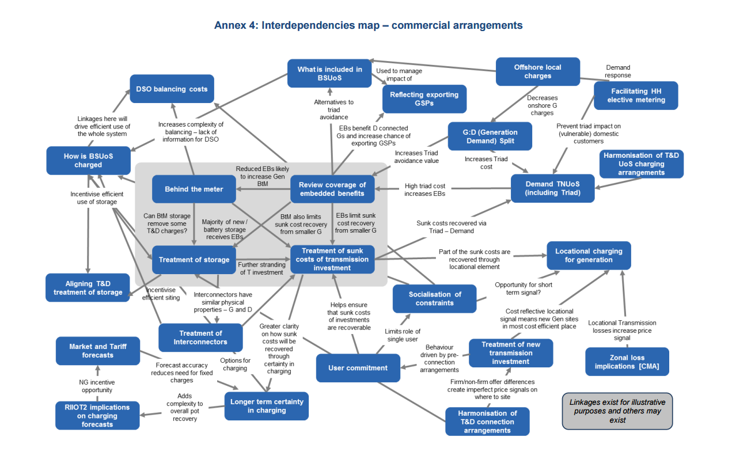
Clearly unpicking the knock-on effects from changes to one element of transmission charging can take time, and it is important that any review has a clear scope and delivery timetable. Equally, it is important that all effects are considered and that the right balance is achieved in securing cost reflective price signals while providing transparency and predictability where possible.
It is our view that the following issues should be considered within the scope of a holistic review;
- The value of embedded renewable generation: Further work is required to fully understand and assess the value that intermittent embedded generation can provide the system. Given the range of ‘cost reflective’ values that have been proposed by interested parties, it is our view that Ofgem is best placed to deliver the necessary independent assessment.
- The principle of net charging: The current ‘net supplier model’ recognises that, in the majority of cases, embedded generators do not use the transmission system and generally bring benefit to it by reducing flows being demanded on the main system. It is our view that this core principle should be retained on a cost reflective basis where generation continues to counter demand.
- Exporting Grid Supply Points: We are in support of development and implementation of cost reflective and consistent charging arrangements for exporting GSPs that drive investment and costs. However, further work is required to ensure generators are exposed to an appropriate price signal, to better understand how DNOs would pass on any charges and to consider wider issues such as the implications for achieving environmental and decarbonisation aspirations and targets.
- The definition of transmission and distribution: the continued definition of the 132kV network in Scotland as transmission means that it is difficult to consider changes to charges for, and treatment of benefits arising from, embedded generators across GB without reconsidering this definition.

- Do you anticipate that underlying network cost drivers are likely to substantively change as the use of the distribution network changes? If so, in what way and how should DUoS charges change as a result?

The networks facilitate access for all types of participant and changes to the overall market design will influence the utilisation of the networks. For example, providers of capacity (at times of system stress) are likely to have infrequent utilisation of the network compared to parties operating primarily in the energy market or parties that provide flexibility which could include services to the local DNO to avoid/defer network investment.
We consider that it is likely that the types of network user will continue to diversify and evolve, which will alter the demand for networks.
This diversity across network users should be accommodated within design and connection arrangements, and therefore network charging.
All parties should pay for the required investment and O&M of the networks in a cost reflective way.
Network entry capacity will continue to dominate the local asset requirements for all users. However, the utilisation of shared network is likely to change. The extent of this change will depend on the incentives (market design) placed on different users to alter their use of the network. For example distribution time of use tariffs could move demand/generation away from peak loading periods.
Network requirements based on conservative assumptions regarding ‘peak’ demand and/or generation output is unlikely to continue to be representative of the ways that networks are utilised.
- Network charges can send both short term signals to support efficient operation and flexibility needs in close to real time as well as longer term signals relating to new investments, and connections to, the distribution network. Can DUoS charges send both short term and long term signals at the same time effectively? Should they do so? And if so, how?
- In the context of the DSO transition and the models set out in Chapter 5 we would be interested to understand your views of the interaction between potential distribution charges and this thinking

Providing price signals for flexibility- Other government policies
- Can you provide evidence to show how existing Government policies can help or hinder the transition to a smart energy future?

Consistency, transparency and predictability of policy are essential, particularly given the long term investment timeframes required for the infrastructure to deliver a smart flexible energy system.

While the UK energy market is effectively liberalised, the UK Government can still find itself in the position of ‘picking winners’ by making the policy environment more or less favourable for certain technologies. At times, such action may be required in order to control costs or encourage innovation. However, the Government’s powers in this regard should be entirely evidence based and exercised with caution as investors will seek reassurance that the policies that underpin investments will endure and are not exposed to unnecessary or excessive policy or political risk.
This issue was reflected by the Competition and Market Authority (CMA) in its energy market investigation. Focussing specifically on the method for allocating CfDs, the CMA recommended that DECC should:
- Carry out and disclose the outcome of a clear and thorough impact assessment supporting a proposal to use its powers to allocate CfDs outside a competitive process; and
- Regularly monitor the division of technologies between different pots, which form the basis of CfD auctions, and provide a clear justification when deciding on the allocation of budgets between the pots for each auction.
The CMA’s proposed remedy underlines the importance of providing a robust evidence to underpin any changes to the policy environment in order to reassure investors that the Government is not unnecessarily distorting the market.

- What changes to CM application/verification processes could reduce barriers to flexibility in the near term, and what longer term evolutions within/alongside the CM might be needed to enable newer forms of flexibility (such as storage and DSR) to contribute in light of future smart system developments?
- Do you have any evidence to support measures that would best incentivise renewable generation, but fully account for the costs and benefits of distributed generation on a smart system?

The committee on climate change has identified that the capacity of renewable energy will need to at least double if we are to remain on track to meet our carbon targets.

With this in mind the Levy Control Framework should serve as a cornerstone of today’s electricity market by providing investors and consumers with a reliable signal as to the scale of investment required to meet the UK’s Fifth Carbon Budget while reconciling the challenges of security of supply and affordability.
Effective communication and long term visibility of the LCF is therefore critical and, while we
Welcomed the announcement of £730m to be made available to less established (pot 2) technologies within the next LCF period, there is some concern that the two cheapest forms of generation – onshore wind and solar - are not currently permitted to access the market.

It is important to note that “at present no form of generation is investable based on the wholesale price alone”. While the Renewables Obligation (RO), Feed-in Tariff (FiT), Contracts for Difference (CfD) and Capacity Market (CM) may differ in the terms and level of support that they offer, they each exist to provide a reliable signal to investors who would otherwise be unable to commit the significant investment required to replace and upgrade the UK’s electricity infrastructure.

It is our view that there is a clear case for further reform of the LCF in order to ensure that the framework is stable, transparent and robust, and that it achieves best value to the consumers.

The roles of different parties in network and system operation
- Do you agree with the emerging system requirements we have identified (set out in Figure 1)? Are any missing?

We recognise that in order to successfully transition to a secure, flexible and low-carbon energy system at the lowest possible cost, the roles and responsibilities of system actors must change and greater dependencies between them will likely develop.
We agree with the emerging system requirements identified in the Call for Evidence and particularly welcome the recognition of the need to create a ‘level playing-field for new and existing flexible technologies, providers and solutions and access to a wide range of revenue streams’.
We would add that the emerging system ought to maintain a focus on low-carbon sources of generation and flexibility, in line with the recommendations set out in the Fifth Carbon Budget from the Committee on Climate Change.
- Do you have any data which illustrates: a) the current scale and cost of the system impacts described in table 7, and how these might change in the future? b) the potential efficiency savings which could be achieved, now and in the future, through a more co-ordinated approach to managing these impacts

- To demonstrate the scale of expected change to our energy system, it is worth noting that the Institute of Engineering and Technology (IET) recently estimated that by 2030 the number of generators providing services to the network will have increased from around 15 to over 600,000
- In order to meet our carbon budgets The Committee on Climate Change states that renewable energy capacity will need to double and that moving towards a flexible energy system presents an opportunity to save £3.5 billion per year by 2030

- With regard to the need for immediate action: a) Do you agree with the proposed roles of DSOs and the need for increased coordination between DSOs, the SO and TOs in delivering efficient network planning and local/system-wide use of resources? b) How could industry best carry these activities forward? Do you agree the further progress we describe is both necessary and possible over the coming year? c) Are there any legal or regulatory barriers (e.g. including appropriate incentives), to the immediate actions we identify as necessary? If so, please state and prioritise them.

It is our view that the transition of Distribution Network Operations (DNO) to Distribution System Operators (DSO) provides a valuable opportunity to help reach our low-carbon ambitions, minimise costs to the consumer, and to create the right market conditions to develop new technologies such as electricity storage, demand side response and active network management.
We note that through a number of trials we have seen strides in network innovation and demonstration of the benefits these models can bring. Active network management (ANM) schemes have enabled generation to connect to the network and demonstrated cost savings of up to 90 per cent.
DNOs have been limited in their ability to adopt these successes at a large scale, by further rolling out existing trials and we would welcome a DSO model taking these innovations forward.
In order to achieve this, is it clear that a DSO model must:
- Create a level playing-field for service providers with clear contractual routes for all parties
- Ensure that market mechanisms are transparent, competitive and aligned at both transmission and distribution level

In order to fully understand how the benefits of these models can be realised, including driving efficiencies in network operation and planning, it is our position that work is required to set out further detail on the scope and operation of the proposed services market.
Any commercial arrangements must be transparent, cost reflective and create a level playing-field for all technologies to compete to provide the most efficient solutions.
The benefits brought by services, and by system flexibility in general, are felt by multiple players in our energy system. However not all these benefits are currently priced in the market. It is imperative therefore that service markets are developed in a way that balances the priorities of different system actors while encouraging the system we require.
A flexible, low-carbon, system will require a variety of service providers including renewable technologies, demand side response and energy storage – all of which rely on a firm understanding of contractual arrangements necessary to secure investment.
It is equally crucial that market mechanisms are effectively harmonised across the transmission/distribution interface. We note that some service providers may already have existing contracts with the System Operator (SO) National Grid or may be looking to additionally participate in those markets. To maximise efficiencies market mechanisms should be developed which are not prohibitive to service providers acting in multiple markets. Equally, it is essential that both markets work together to avoid driving inconsistent behaviour.
Should participation in a DSO service market preclude providing services to others, this must be appropriately reflected in price signals in order to appropriately incentivise service providers.
We additionally note that a number of key enabling technologies will be required to support the transition to a DSO, including: enhanced monitoring, improved modelling and prediction tools, control and automation of assets, communication and distribution management systems and cyber security and data protection. We would encourage further discussion on how to further develop these enabling technologies to benefit all system actors and users
We agree that these changes should be tackled holistically across all system actors and support the development of transparent and integrated markets to catalyse system changes. Emphasis should be placed on remove regulatory barriers to enable industry to develop appropriate solutions.
Determining System Need
Clear and transparent processes will need to be developed for determining system need. While the Balancing Mechanism can inform decision making at the transmission level, no such signal exists at distribution to prompt a DSO to reinforce the network or to take certain flexibility actions. This will have to be created with care not to undermine the the value flexibility providers bring to the system. We would caution against extending the NOA processes as it currently exits. The current process risks subjective judgements being made by the SO regarding which network users will come forward. As the network becomes more sophisticated, the determination of network need will have to take better account of stakeholder requirements, including access requirements and flexibility offerings. We would welcome further consideration of this.
b) How could industry best carry these activities forward? Do you agree the further progress we describe is both necessary and possible over the coming year?
We agree that these changes should be tackled holistically across all system actors and support the development of transparent and integrated markets to catalyse system changes. Emphasis should be placed on remove regulatory barriers to enable industry to develop appropriate solutions.
We have previously supported taking a modular approach to these activities – rolling out or deepening existing schemes, and learning from them.
c) Are there any legal or regulatory barriers (e.g. including appropriate incentives), to the immediate actions we identify as necessary? If so please state and prioritise them.
We would be keen to understand whether there are any barriers in existing licensing arrangements, including RIIO Frameworks and existing ICE commitments which would prevent network operators from taking these initiatives forward.
It is worth noting the impact of certain EU network codes, including the Requirements for Generators. This will come into force in 2019 and includes elements of controllability for generation above 800w.

- With regard to further future changes to arrangements: a) Do you consider that further changes to roles and arrangements are likely to be necessary? Please provide reasons. If so, when do you consider they would be needed? Why? b) What are your views on the different models, including: i. whether the models presented illustrate the right range of potential arrangements to act as a basis for further thinking and analysis? Are there any other models/trials we should be aware of? ii. Which other changes or arrangements might be needed to support the adoption of different models? iii. Do you have any initial thoughts on the potential benefits, costs and risks of the models?

We agree that roles and market arrangements will likely have to adapt as the energy system develops, and we support pragmatism in developing arrangements that are flexible and resilient across a broad range of scenarios.
As previously discussed, the creation of an overall vision for the energy system would offer strategic direction and help minimise the likelihood of developing roles and markets that do not reflect system requirements
b) What are your views on the different models, including:
i. whether the models presented illustrate the right range of potential arrangements to act as a basis for further thinking and analysis? Are there any other models/trials we should be aware of?
Member input sought
ii. Which other changes or arrangements might be needed to support the adoption of different models?
iii. Do you have any initial thoughts on the potential benefits, costs and risks of the models?
Harmonisation between transmission and distribution systems will be key to models and market structures that enable the development of a flexible energy system. Models need to be transparent, inclusive and create a level playing-field for service providers.
The Call for Evidence rightly notes that there could be interdependencies between the models and market structures developed and other aspects of the energy system, including network charging and wider commercial arrangements. We support the recognition that any changes would need to be considered holistically.
Some DNOs are already proactively considering models and market structures for transitioning to a DSO, and the impacts of these models across the energy system and we would encourage a coordinated approach with the DNOs when giving further consideration to models.

Innovation
- Can you give specific examples of types of support that would be most effective in bringing forward innovation in these areas?
- Do you think these are the right areas for innovation funding support? Please state reasons or, if possible, provide evidence to support your answer.

It is our position that driving innovation in the below areas can enable the development of a flexible, secure, cost-effective and low carbon energy system.
•Flexible Networks: The Committee on Climate Change states that achieving our carbon budgets with a ‘more flexible power system’ has the potential to save consumers £3bn-3.5bn per year11. Securing this flexibility will require a range of new technologies such as Active Network Management (ANM) systems, demand side response, storage and will encompass efforts to better operate networks, including transitioning to a DSO.
•Energy Storage: Significant volumes of energy storage have been awarded contracts in both the Enhanced Frequency Response services and the Capacity Market tenders. However, storage technologies have a number of other benefits which currently aren’t priced in the market (including enabling increased renewables capacity and potentially deferring network upgrades). Innovation, both directed at storage technologies themselves and in the mechanisms to encourage storage technologies to market will be required to realise these benefits.
•Energy Systems Integration: A whole systems approach will be required to facilitate a transition a smart and flexible energy system. Holistically considering electricity, heat and transport will allow us to drive efficiencies in our system and tackling the energy trilemma. Developing new technologies, market structures and business models will be essential.
•Low-Carbon Heat: Heat accounts for 46 per cent of UK energy demand8, supports 32,600 jobs and had a turnover of £4.9bn in 2013 alone9. However, only 4.9 per cent of total heat demand was renewable in 201410. Decarbonising the sector will mean fully developing new technologies, supporting their large-scale deployment and integrating them into our wider energy system.
•Innovative Renewable Generation: If we are to meet our climate budgets, and deliver a secure, low-cost and low-carbon energy system, increased renewable generation capacity will be required.

ANNEX 1
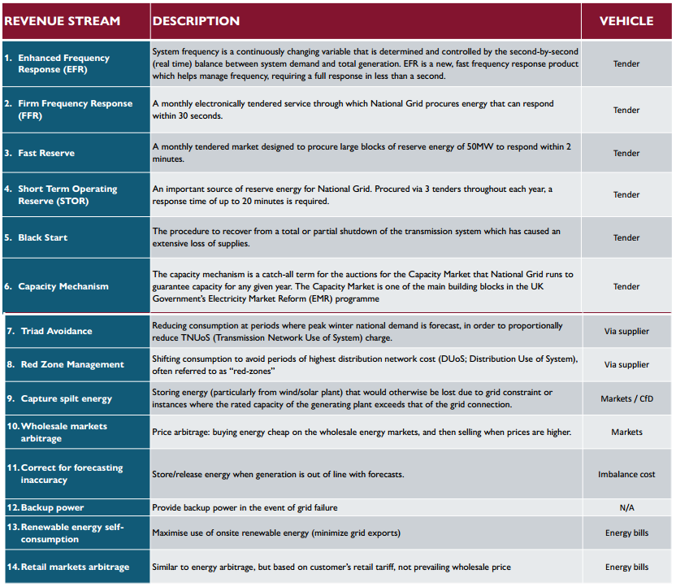

https://www.scottishrenewables.com/news/new-report-sets-out-blueprint-investment-storage/
http://www.theiet.org/sectors/energy/resources/modelling-reports/index.cfm
https://www.scottishrenewables.com/publications/electricity-storage-cracking-code/
Annex 1 – revenue streams
http://www.e3g.org/docs/E3G_Electricity_Market_Reform-_Unfinished_Business_Simon_Skillings_120515.pdf
https://assets.digital.cabinet-office.gov.uk/media/559aacbee5274a1559000017/EMI_Notice_of_PFs.pdf
http://www.theiet.org/sectors/energy/resources/modelling-reports/index.cfm
http://innovation.ukpowernetworks.co.uk/innovation/en/Projects/tier-2-projects/Flexible-Plug-and-Play-(FPP)/

