Transmission Network Use of System Charges: a strategy for a strategically planned energy system

Executive Summary
The current Transmission Network Use of System (TNUoS) framework aims to deliver a cost-reflective signal to market participants to influence the location of developments. It aims to provide a price signal to developers to reflect the cost of the transmission reinforcements their project drives. This is in addition to the wider range of other locational factors that influence investment decisions. In doing so TNUoS aims to support an economically efficient development of the electricity system by providing an incentive for developers to site generation closer to where the electricity will be used.
While TNUoS may have been a logical approach in a fossil fuel-based system where it was possible to move the fuel to the point of generation, in a renewables-based system, where generation must be located where renewable energy and space are available, TNUoS is no longer an effective locational signal. Scottish Renewables (SR) has long held the position that the locational signals involved in TNUoS, which are substantially higher for generators in Scotland compared with southern GB, form a major barrier to the development of a net-zero electricity system.
SR also holds that in practice the current TNUoS methodology has failed to deliver on its own objectives. This is because, in practice, the price signal delivered through TNUoS is too uncertain at the point of Final Investment Decision for renewable projects, and because there is little optionality over location for onshore wind (given the availability of wind resource and lack of planning support in England) and offshore wind (given centralised decisions over seabed leasing and network design).
UK government, Ofgem and the ESO have all indicated there will be a significantly greater role for ‘strategic planning’ of the electricity and energy systems in future. This will evolve from the Holistic Network Design (HND), to encompass both transmission network planning through the Centralised Strategic Network Plan (CSNP) and wider system planning through the Strategic Spatial Energy Plan (SSEP). This move towards a strategically planned energy system and transmission network means that, as we move towards a net-zero electricity system, locational TNUoS will be much less useful even in theory.
SR proposes that there needs to be a new approach to transmission charging which aligns with the strategic planning model being taken forward. SR’s proposed position is:
- The cost of any element of the transmission network that is ‘strategically planned’ should be met through a non-locational charge, reflecting the fact that the cost is driven by meeting wider societal ambitions, rather than by specific developer decisions.

- The cost of any element of the transmission network which continues to be ‘market driven’ should continue to be covered by a cost-reflective methodology.

- The future development of transmission charging and evaluation of its ability to deliver good outcomes for consumers, including minimising consumer bills and delivering net-zero, needs to specifically consider the impact of the interaction between TNUoS, CfDs and wider market frameworks.
Removing the cost of strategically planned network infrastructure from cost-reflective charging can have the following beneficial impacts:
- Remove the tension between a decarbonisation plan that relies on renewable generation in Scotland and a network charging regime that acts to disincentivise renewable generation in Scotland.
- Reduce consumer bills by identifying and removing interactions between network charging and the CfD (and potentially other elements of electricity market frameworks) which lead to windfall transfers between consumers and some, typically more southerly, generators.
- Reduce cost to customers of the large investment required to deliver net-zero by enabling generation investors to more accurately predict, at the point of key commercial decisions, what their project lifetime network costs are likely to be. This reduces investor risk, reduces the cost of capital and therefore the cost of the electricity subsequently generated.
- Reduce consumer bills by removing uncertainty and therefore risk from financial investment decisions.
SR’s proposed position on TNUoS is based on the clear signal from government that strategic planning will be an important part of developing the GB electricity system. However, SR has not yet defined its wider position on how strategic planning should interact with markets in terms of planning and allocating capacity across the country.

The issue: current arrangements for TNUoS
TNUoS has long been regarded as a significant barrier to the development of renewable generation in Scotland. This is due to the large and unpredictable differences in locational generation charges. Under the current system, generation TNUoS aims to be ‘cost-reflective’ in that the charges for a particular location should reflect the cost of marginal additional investment in the transmission network that generation (or demand or storage) in a particular location creates.
In Autumn 2023 National Grid ESO (NGESO), for the first time, published ten-year forecasts of TNUoS using the current methodology and current expectations for the build out of the transmission network and the evolution of generation and demand on the electricity system. This confirms that the current locational differential will likely grow substantially by the early 2030s. Figure 1 shows the values in both £/kW and £/MWh for a renewable generator with a capacity factor of 45%. The charges in the ten-year forecast were calculated prior to the ESO completing their ‘beyond 2030’ work which recommends a further £58bn investment in network infrastructure. This additional investment would almost certainly lead to further significant increases in TNUoS.
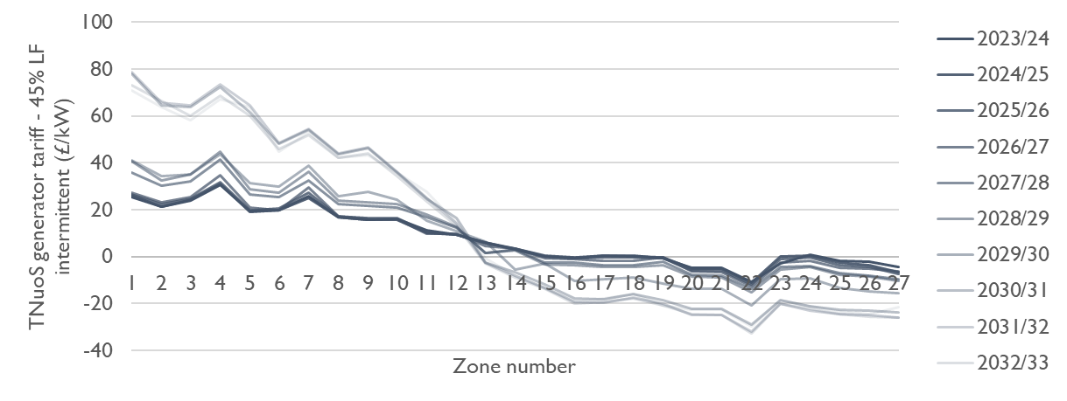
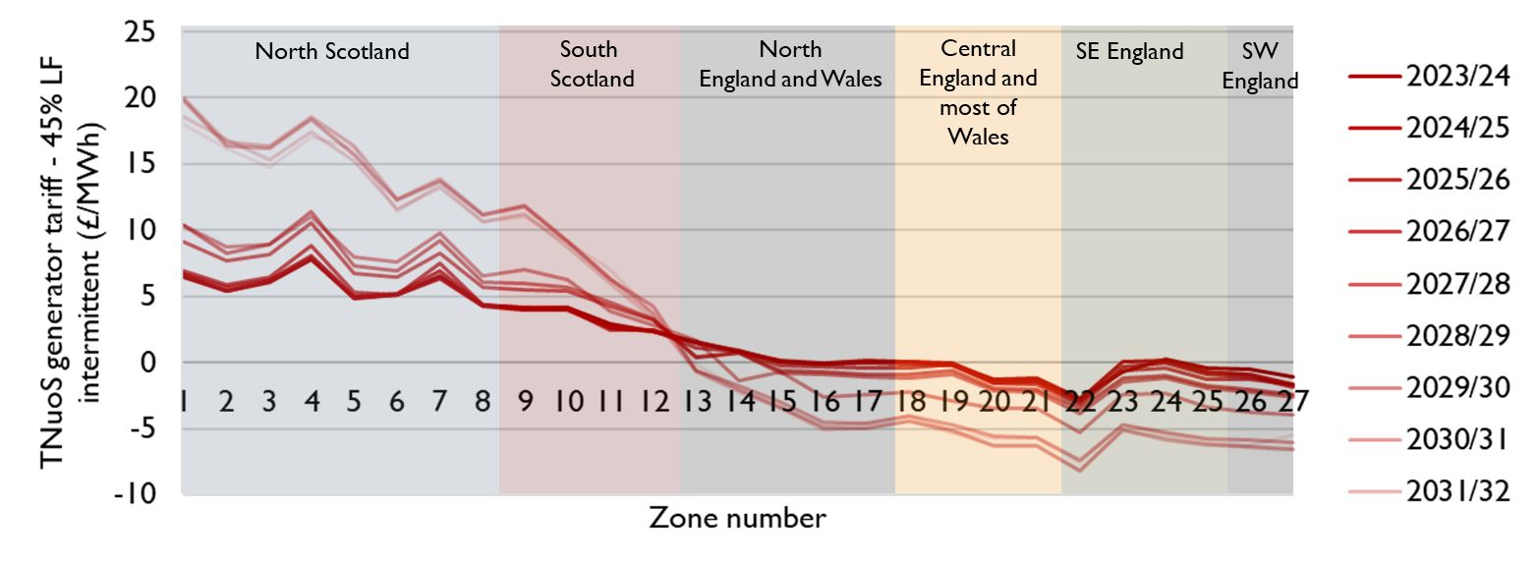
Figure 1: Ten-year TNUoS Forecast made in October 2023 for an intermittent generator with 45% load factor. Presented in £/kW (top) and £/MWh (bottom).

In 2030-31 the differential between north Scotland and south England could be as high as £111 / MW or £28.11 / MWh. SR’s view is the scale of this locational variation is an issue for five reasons:
- The uncertainty in TNUoS and the timescales for the development of, and payback of investment in, renewable projects means that locational TNUoS signals fail to effectively influence project siting. Rather it drives up the cost of capital leading to higher consumer costs.
- The current methodology used by NGESO fails to deliver a truly cost-reflective signal, even in theory.
- Considering the growing focus on strategic planning for the energy system, the rationale for locational signals is removed for much of the transmission network.
- Locational TNUoS creates a significant barrier to the development of wind in the locations which are most suitable for wind farms and therefore fails to deliver on a focus for net-zero;
- Through interactions with CfDs, consumers will end up paying more due to locational TNUoS.
Points 1 and 2 are long-standing issues which SR has regularly raised, including during the last full-scale review of network charging, Project TransmiT, which concluded in 2012. At the time Ofgem concluded that moving away from cost-reflective charging would come ‘at disproportionate cost to consumers and the power sector; would exacerbate existing regional patterns of fuel poverty; risk straying into areas of UK government policy around the degree of support for low carbon generation, which could cause confusion’.
However, the context has changed significantly since then. Points 3, 4, and 5 represent new issues that need to be considered in deciding on the most appropriate way forward. There are three key developments since the early 2010s. Firstly, over the past year, there has been clear signalling from the UK government, Ofgem and NGESO of the intention to move to a more strategically planned energy system. Secondly, net-zero targets were introduced for the UK and Scotland in 2019 and more recently the UK government committed to a net-zero electricity system by 2035. Thirdly, apart from merchant projects, all new renewable capacity is supported by CfDs which leads to a feedback mechanism between variations in TNUoS and CfD clearing prices.
The current TNUoS Task Force, of which SR is an active member, is looking at options to improve the current methodology for the short to medium term. However, SR believes that the time is now right to push for a fundamental, principle-led, approach to how we pay for our transmission network which works within the context of the modern electricity system and the overarching need to decarbonise the energy system, attract inward investment and delivering net-zero benefits for consumers.

The move towards strategic planning to deliver net-zero
The development of the transmission network over the past few decades has been driven by a ‘follow the market’ approach with transmission planning first developing forecasts (or scenarios) of where market development is likely to go and designing a network in response.
In practice, this was implemented by the ESO’s annual FES / ETYS / NOA process, summarised in Figure 2. The Future Energy Scenarios (FES) laid out four futures that the electricity system might follow including what type of generation would come forward and in which location. The Electricity Ten Year Statement (ETYS) then identified the capability required from the transmission network in each scenario. Finally, the Network Options Assessment (NOA) identified specific transmission projects that would deliver that network capacity. The process has been repeated annually with transmission investment decisions adjusted year-on-year.
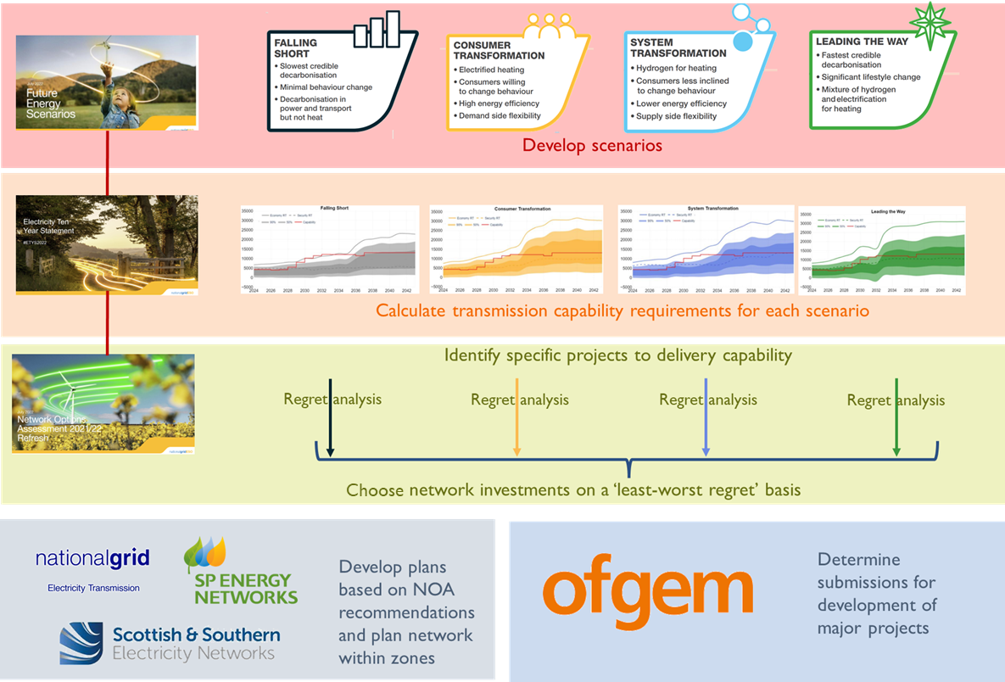
Figure 2: Summary of the transmission planning approach used over the past ten years.
More recently, there has been a recognition that a purely ‘follow the market’ approach to network planning was not delivering the network capacity needed to meet key government targets, particularly the 2030 UK government target for 50 GW of offshore wind. This led to the Holistic Network Design (HND) based on a single pathway to meet the 2030 target. An HND follow up exercise (also called the tCSNP2) was published under the banner of ‘Beyond 2030’ in March 2024.
The HND is now developing into an enduring process, the Centralised Strategic Network Plan (CSNP). This is currently expected to:
- Include a central short-term pathway for the electricity system which will aim to meet key government targets
- Include longer term sensitivities in its outlook towards 2050 and a counterfactual that does not meet government targets for comparison
- Lock in a firm delivery pipeline of work for transmission network development for the first 12 years
- Over time integrate the Strategic Spatial Energy Plan (SSEP) recently mandated by the UK government
Figure 3 provides an overview of how the new CSNP maps onto the older annual process.

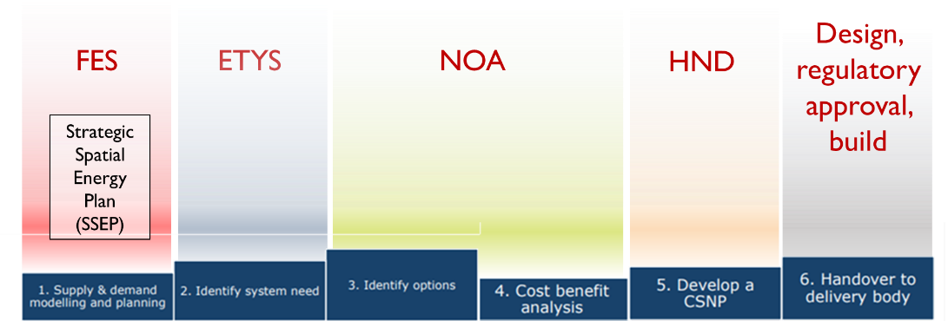
Figure 3: Summary of how the six stages of the CSNP will integrate previous activities carried out across the FES / ETYS / NOA process, the evolution of the HND, and the establishment of the SSEP.
The SSEP is a critical part of this strategic approach and extends the concept of ‘strategic planning’ from just the network to the entire energy system. Although it will take time to develop, the government’s ambition for the SSEP and its role in driving strategic network planning is clear:
‘The SSEP will bridge the gap between government policy and infrastructure development plans. It will ultimately cover the whole energy system, land and sea, across Great Britain and will support the government in tandem with energy markets to determine the optimal location of energy infrastructure needed to transition to a greater supply of homegrown energy’ (UK Government Transmission Acceleration Action Plan, 2023)
Of course, the development of these documents comes into a context where strategic planning already exists. For example, seabed leasing is a centralised process which identifies specific locations where offshore wind can develop.

What makes sense for transmission charging in a strategically planned world?
An SSEP could ultimately take various forms. Nick Winser, the UK Government’s Electricity Network Commissioner suggested in Summer 2023 that ‘it is unrealistic to imagine that we can wait and see what energy sources and demands arise, then hope to build the necessary networks in time’ rather we need an SSEP for GB which ‘forecast[s] the supply and demand characteristics and their likely whereabouts’ which would then ‘create an overarching reference for many energy network plans such as the CSNP’.
SR expect that an SSEP will ultimately provide a regional breakdown of supply and demand including, for example, indications of the capacity of various generation technologies in each region of the country. The network will then be planned to facilitate the interconnection of those regions and the efficient use of the generation capacity planned for each.
If the transmission network is built in line with this model, it will no longer make sense to argue that particular generators are driving new transmission investment. Rather, particular generation projects are utilising the capacity that has been created through the plan. In fact, it will be important to encourage generation to locate in line with the strategic plan.
For this reason, within the granular resolution of the SSEP and CSNP strategic planning processes, it would not be useful to provide a cost-reflective price signal to influence locational investment decisions.

The interaction with CfDs
CfDs are now the only mechanism used to support the development of renewables and, apart from a small amount of capacity which is being taken forward under a merchant basis, all new wind farms are being developed through a CfD mechanism.
When bidding into a CfD auction, developers need to estimate their project costs and the strike price required to deliver sufficient revenue during the first fifteen years of operation to make their project financially viable.
Network charges now represent the most important cost differentiator between projects. As shown in Figure 1 (b), this could be as high as £28 / MWh under the current TNUoS model by the early 2030s. Given that the capacity of renewables needed to deliver a net-zero electricity system is significant, this means that to meet our targets, CfD auctions will need to procure generators in the more expensive TNUoS zones. CfD auctions are ‘pay as clear’ and high-TNUoS projects are likely to set the strike prices in many auctions leading to a windfall for more southerly generators. The interaction is illustrated in Box 1.
Box 1: Illustration of CfD / TNUoS interaction
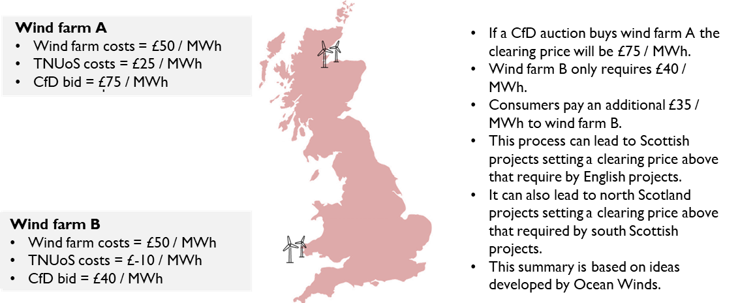

As a result of interaction with CfD auctions, locational TNUoS has the potential to drive higher costs for consumers and lead to a transfer from consumers to generators, specifically to more southerly CfD generators.

A principles-led position
Over the past few months, an SR Task & Finish Group has been exploring the potential to champion a new approach to network charging that reflects the changes described above. Any new approach should consider Ofgem’s existing principles-based approach to regulation, most recently articulated in the September 2023 TNUoS Open Letter:
- Cost-reflectivity
- Enabling net-zero
- Fairness
- Predictability
- Transparency
SR’s view is that the current TNUoS methodology does not deliver on several of these principles, and at various times in the past, SR has challenged Ofgem on that basis. Whilst Ofgem has previously remained strongly committed to locational charging, the September 2023 open letter signals a potential change in that position: ‘transmission charging reform effort would likely be characterised by the need to make material trade-offs between the charging principles’ (pg 9) and that ‘In principle, the more prescriptive that planning processes are on siting decisions, the less useful a TNUoS locational price signal may be as the ability of new assets to respond to such signals would reduce’ (pg 25). A brief commentary on the relationship between the three elements of SR’s draft position and Ofgem’s principles is given in Table 1.

SR is proposing three principles to use in developing its position and engaging with Ofgem, NGESO, Government and other stakeholders interested in transmission charging:

- The cost of any element of the transmission network that is ‘strategically planned’ should be met through a non-locational charge, reflecting the fact that the cost is driven by meeting wider societal ambitions, rather than specific developer decisions.

- The cost of any element of the transmission network which continues to be ‘market driven’ should be covered by a cost-reflective methodology.

- The future development of transmission charging and evaluation of its ability to deliver good outcomes for consumers, including minimising consumer bills and delivering net-zero, needs to specifically consider the impact of interactions between TNUoS, CfDs and wider market frameworks.

Table 1: Commentary on how the SR proposal aligns with Ofgem's principles.
Ofgem Principle | Commentary
Cost-reflectivity | Point 1 reflects the fact that in a strategically planned energy system, the design of the bulk-transportation ‘national’ transmission network is no longer driven by market decisions and therefore individual projects no longer drive network costs. Locational charging in this context is no longer cost-reflective. Point 2 acknowledges that on a regional level, below the likely granularity of the SSEP, there could remain a market-led approach to location. Costs associated with regional elements of the transmission network could continue to be driven by the market and therefore a locational charge for these elements may continue to align with a cost-reflective approach.
Enabling net-zero | The current TNUoS approach is widely acknowledged to be a barrier to net-zero. Ofgem’s new net-zero mandate, to be formally bestowed through the Strategy and Policy Statement (SPS) , raises the importance of better aligning TNUoS with net-zero and highlights Ofgem’s need to better align the two.
Fairness | The locational variation in TNUoS is likely to be driving significant consumer detriment through its interaction with CfDs leading to an unnecessary windfall for more southerly CfD holders. Therefore, the combination of the three elements of the proposed position would increase the fairness of the charging system.
Predictability | Points 1 and 2 are likely to remove most locational charges from generators. This will significantly reduce the high levels of uncertainty associated with TNUoS for the most geographically extreme zones. Locational charges will remain within regions however the scale of variation for these components is likely to be much smaller than under current arrangements.
Transparency | The NGESO share the current TNUoS model and is transparent about the methodology and assumptions used. However, the complexity of the process hinders transparency and a simpler system, based on the proposals here, would tend to increase overall transparency.

What would be the impact on Scottish renewable projects?
Removing strategically planned network infrastructure from locational network charging would reduce the future TNUoS differential between different parts of GB.
It would also increase certainty for investors over future TNUoS charges because the uncertainty over the timing and cost of most large-scale, national transmission infrastructure would be removed from locational calculations. This would also bring a considerable reduction in energy costs for consumers.
As an example, the growing difference in forecasting charges between Scotland and south England and Wales is largely driven by the new HVDC bootstraps being built on the east coast between Aberdeenshire / East Lothian and north east England. The cost, timing and methodology of how to reflect HVDC costs in the current TNUoS methodology creates significant uncertainty for developers and therefore investors. If these new assets were classed as ‘strategically planned assets’ much, if not all of the growth in the TNUoS locational differential would be removed.
The scale of the impact would depend on the specifics of a new framework. For example, how network infrastructure is categorised as strategically planned or market driven. For example, it may be possible to argue that the future electricity system will be strategically planned at a relatively high level of geographical granularity and that almost all new transmission infrastructure is strategically planned.
Alternatively, it may be that strategic planning only applies at an inter-regional level (e.g. treating Scotland as a region or north Scotland / south Scotland as two regions) and that the market is expected to deliver the distribution of capacity within a region. This would mean that transmission infrastructure within a region would likely be categorised as market driven and remain cost-reflective.
One area which faces particularly high TNUoS charges is the Scottish Island groups – Orkney, Shetland and the Western Isles. These areas have significant renewable resources and are being connected by new transmission capacity. It will be important to consider whether these links are strategically planned and therefore if they should form part of the cost-reflective locational charging base or not. The decision could have significant implications for the development of renewables on the Islands.

Why is SR not arguing for a complete removal of locational network charges?
Some elements of locational price signals could play a useful role in helping the electricity system develop efficiently, and ultimately, if well designed, they could help deliver value to electricity consumers. This is only true if locational signals are delivered in a context where market participants can respond efficiently to them, and where market forces are truly driving investment decisions, including decisions on location. However, where it is true, SR is willing to work with Ofgem and the sector to find ways to design locational charges in a way that can deliver a useful signal. SR’s view is that the scope of ‘market-driven’ decision making is significantly reduced in a strategically planned system, and therefore the scope of locational network charges should be correspondingly reduced. But SR accepts that there is likely to remain a reduced role for market-driven decisions on location and therefore there may remain a role for some elements of locational network charging.
Another consideration is that of fairness, one of Ofgem’s core principles. During the discussion on charging reform over the past few years, there have been a range of views expressed on what constitutes fairness. These range from a strongly cost-reflective view where fairness is associated with everyone (consumers and generators) paying for the parts of the network they use, to an opposing view where fairness is associated with equity of costs for consumers: all consumers paying the same for access to the electricity system.
In Ofgem’s Targeted Charging Review, and Access and Forward Looking Charges SCR Ofgem concluded that “fairness” was primarily relevant for charges paid by demand customers. By contrast, Ofgem concluded that generators should not face charges for revenue collection purposes, while generator charges that did remain should be driven by principles of effectiveness and cost reflectivity.
However, there is a wider argument that where network infrastructure is built specifically to provide access for particular groups of generators to the wider market, those generators should contribute more towards that network than others. Application of this principle could lead to some degree of locational charging, but only where it is consistent with other objectives, particularly delivering net-zero.
It is also important to note that a near complete removal of locational charges is consistent with the draft position if it becomes clear that all elements of the transmission network will, in future, be strategically planned.

Next steps
The TNUoS Task & Finish Group will continue to develop the principles over the coming months and develop evidence to support SR’s position. This will include exploring how the principles can be put into practice, and important questions that need to be considered. For example:
- What criteria should be used to categorise strategically planned and market-driven network reinforcements?
- If locational charges are removed from strategically planned network infrastructure how will those costs be recovered?
- What is the scale of consumer detriment stemming from the interaction between TNUoS and CfDs?
- What is the benefit to consumers of reducing or removing uncertainty and therefore risk from TNUoS forecasting to support better investment decisions.
For those interested in commenting on the proposed position laid out in this paper please contact Stephen McKellar at smckellar@scottishrenewables.com.

https://www.nationalgrideso.com/document/288956/download
https://www.nationalgrideso.com/future-energy/beyond-2030
See pg 5: https://www.ofgem.gov.uk/sites/default/files/docs/2012/05/transmit-scr-conclusion-document_0.pdf
https://www.nationalgrideso.com/future-energy/beyond-2030
See here for detail: https://www.ofgem.gov.uk/publications/decision-framework-future-system-operators-centralised-strategic-network-plan
See page 12 https://assets.publishing.service.gov.uk/media/65646bd31fd90c0013ac3bd8/transmission-acceleration-action-plan.pdf
https://www.gov.uk/government/publications/accelerating-electricity-transmission-network-deployment-electricity-network-commissioners-recommendations
See page 9: https://www.ofgem.gov.uk/sites/default/files/2023-09/Open%20letter%20STC_110923.pdf
https://www.gov.uk/government/consultations/strategy-and-policy-statement-for-energy-policy-in-great-britain

